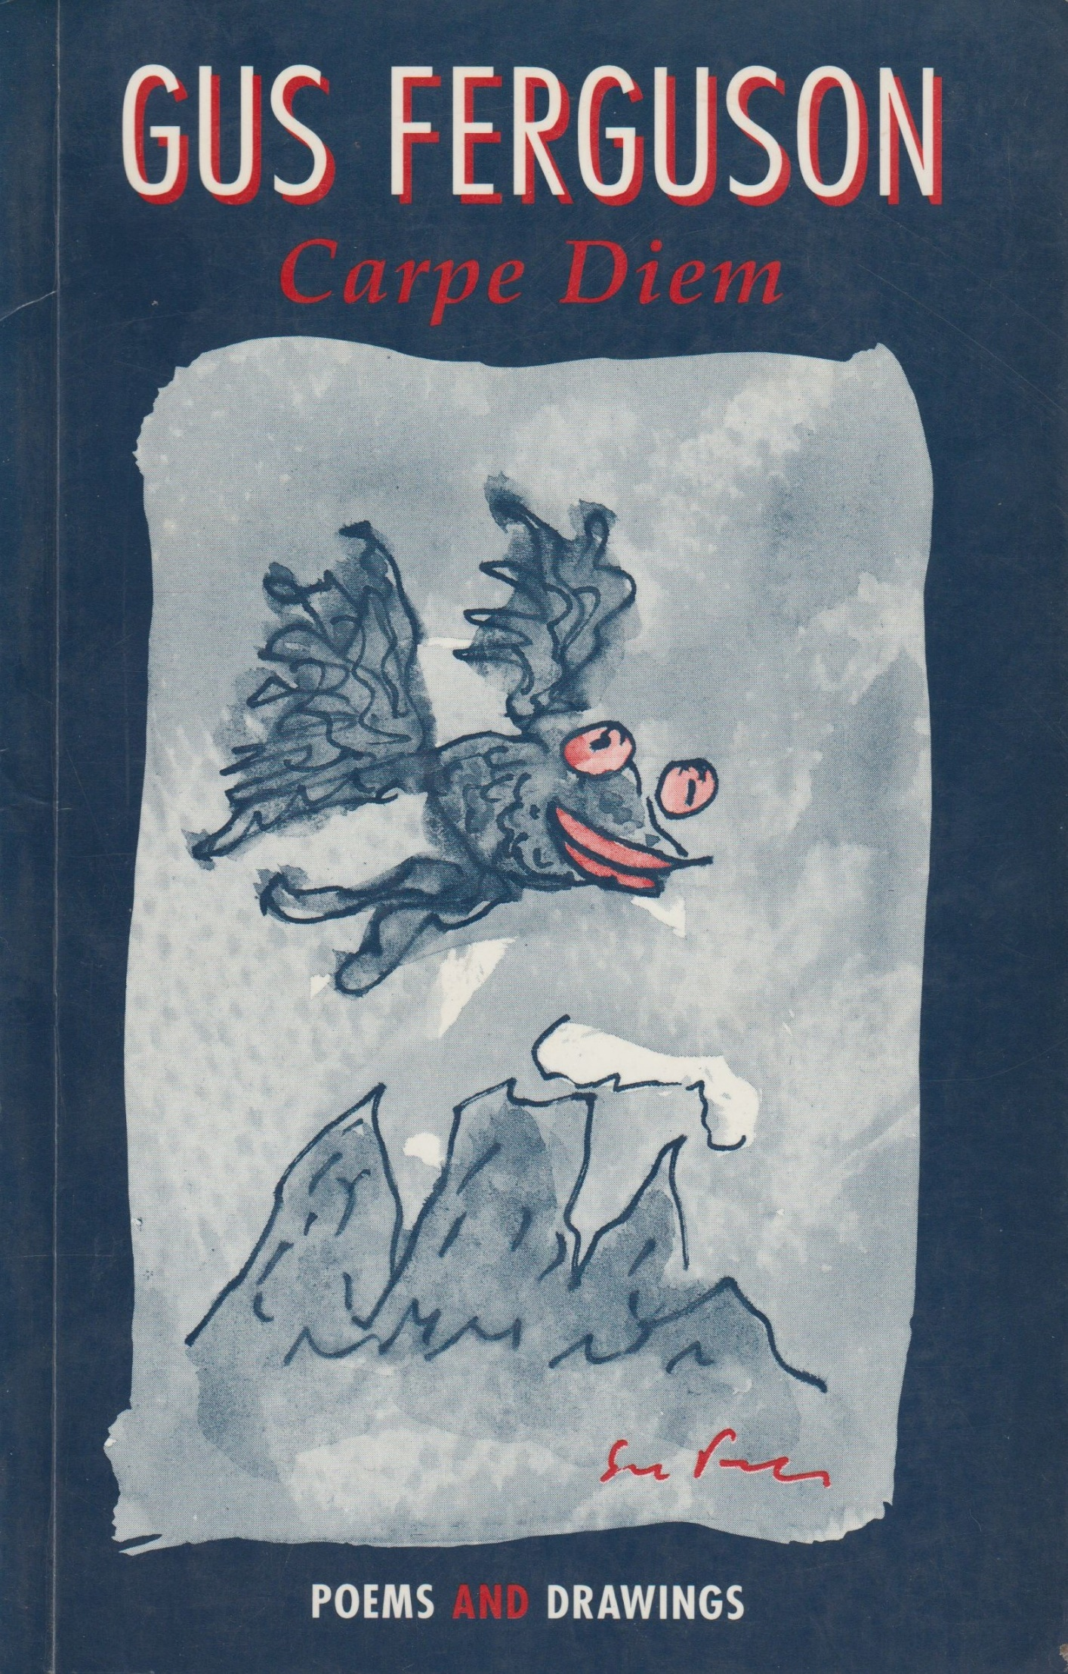
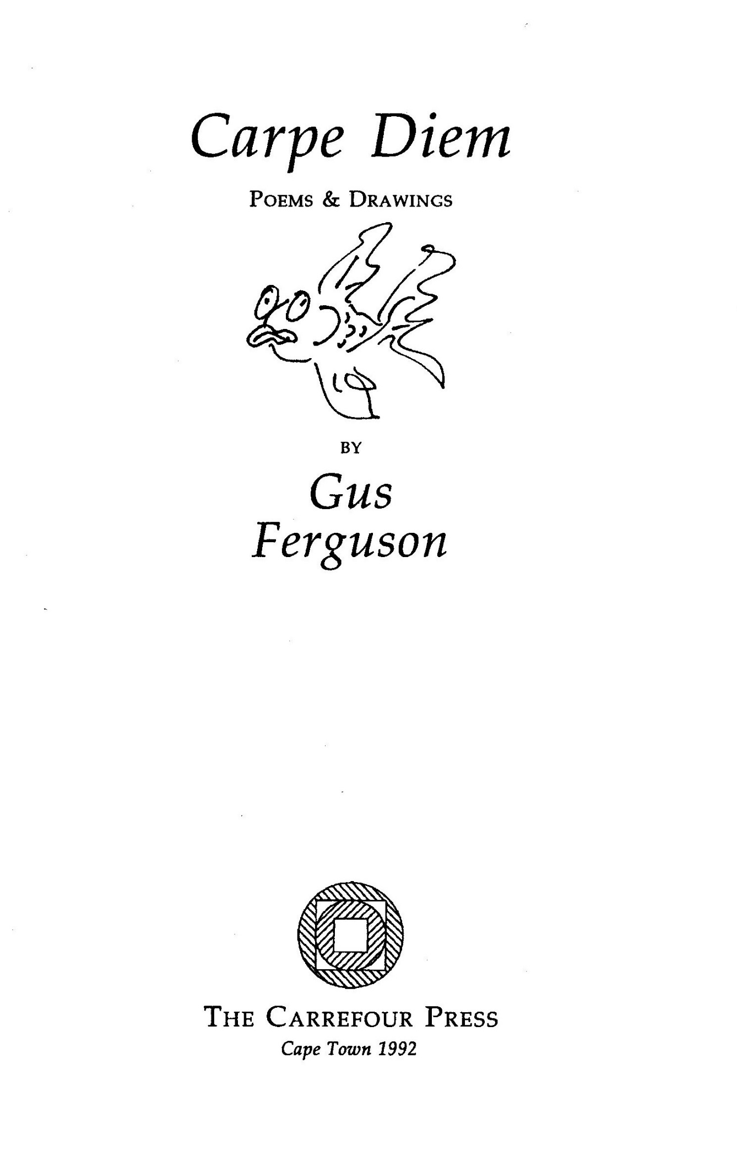
CONTENTS

Carpe Diem ' 9
Another Carp ' 10
Good Theology, Bad Move ' 10
Lot's Wife and Vinegar ' 11
Whose Constant? ° 12
Evidence? ' 12
Space—Time for Beginners ' 12
Quarry Pond Samsara ' 13
Pythagoras of the Smalls ° 14
Modern Miracle ' 16
Snail Atman ' 17
Conjunction ' 17
Omward Bound ' 17
On First Creeping into a Poem by Dylan Thomas
Why Snails are Vegetarian ' 18
Nostalgia for the Truth ' 19
The Amoeba is Immortal ' 20
Justification ¢ 21
Maslow was Wrong ' 21
Sailing Alone Around the World ' 22
The Walls of Redwing ' 23
Businessmen in Flight ' 24
Innocent Experience ¢ 25
Thirteen Haiku ' 26
Yet in Arcadia Ego ' 28
Midlife Crisis ' 28
Twenty Questions ' 29
Mightier than the Sword ' 30
Call and Response 0 34
Tending to Eden ' 35
Fugue for Rhythm and Wind ¢ 36
Two Reggae Rhythms for David ' 36
M C Koei ' 37
Narcissus ' 37
Death on the Road I 38
The Armageddon Trail ' 40
(N0)Thing 0 40
Life Sentence ' 41
Bill MacFeather ' 42
Matthew Farnham ¢ 42
RA in Bow 43
Hinault's Not What He's Missing 44
Book Club 45
Blesséd are the Meek 46
Up and Up Mount Everest 48

-- for --
NICKY & SUE & SANDRA
& LIONEL

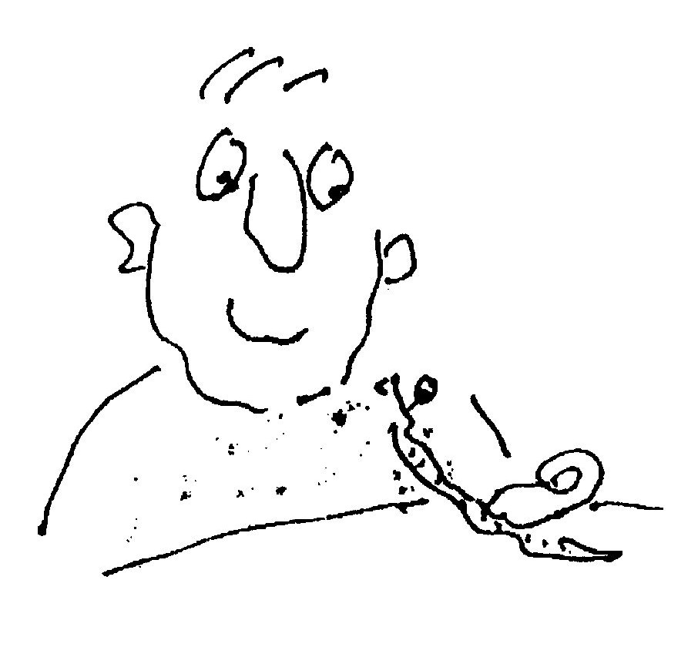

Carpe Diem
—for Lionel Abrahams

A goldfish in a goldfish bowl
Surveyed the world outside
And felt completely in control
Of everything he spied.

Thought he: ”I’m in my element,
My glass, a faithful lens
That shows a foggy firmament
That wobbles and distends.

"An ever-shifting universe
Of ectoplasmic forms
Beyond all known parameters
Of finite, fishy norms.

”And yet, this mystic interplay
Does serve me with such love
That I am blessed everyday
With manna from above."

Another Carp

A must for every aesthete yuppie —
The Japanese designer guppie:

Obscured by lily pads and fronds
It undulates in shadowed ponds,

O "Living Gem”, ”Elusive Ioy”
So shy, and aptly labelled, Koi.

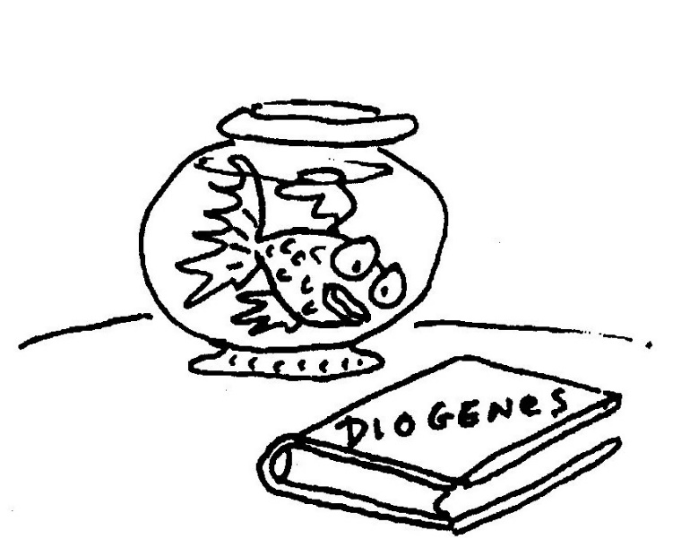

Good Theology, Bad Move

—Ascension Day 1991

The sad, incarcerated carp
Who reasons perfectly:
"Could I but smash this bowl of glass,
My spirit would be free.”
Lot's Wife and Vinegar

Approaching Zoar* one winter’ s night
We saw a most amazing sight
An ovoid moon of massive size.
We hardly could believe our eyes:

It lumbered upward from the earth.
Encumbered by its awkward girth,
Its surface pale and pocked with crater;
It looked just like a peeled potato.

So now we wait, with smacking lips,
For new moon, star-fried, crescent chips.

‘Close to Oudtshoorn and to Sodom (Genesis 19.22)

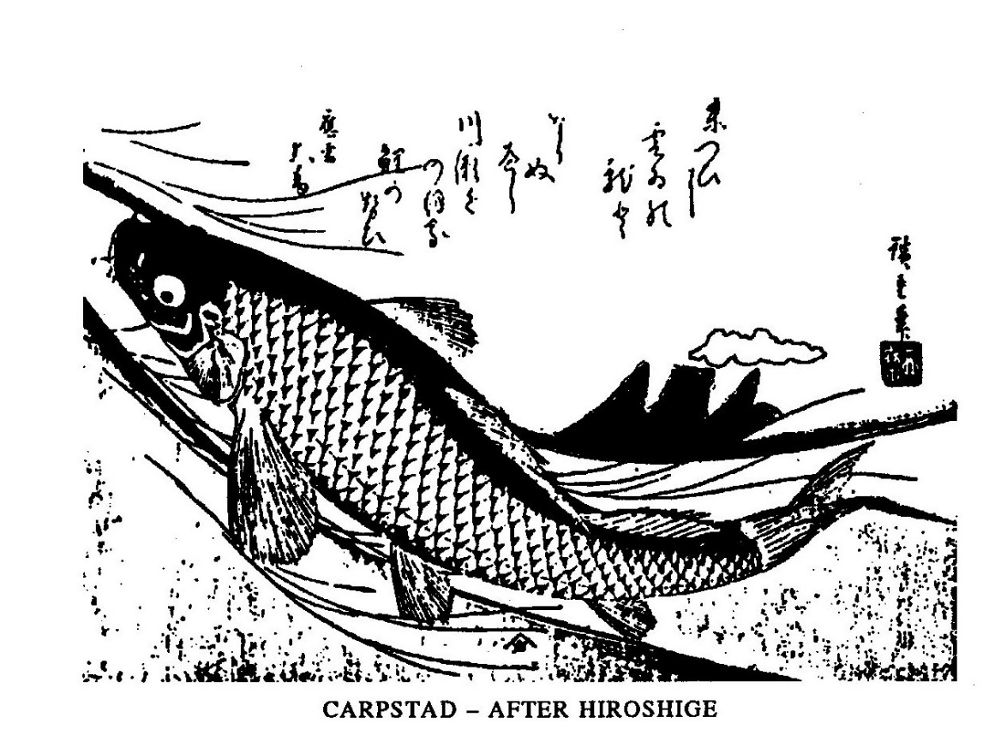
Whose Constant?

There once was a poet called Frank
Of low metaphorical rank:
He just couldn't see
A bookshelf or tree
In a length of timberyard plank.

Evidence?

After the flood when
The waters subsided
God said to Noah:

”Come out of the ark."
And all the wild beasts
And all kinds of cattle

And all of the birds
And all of the creatures
That crawl on the earth

Disembarked from the ark.
Excepting of course,
The wood-borer beetles.

Space-Time for Beginners

There was a physicist called Joe
Who wanted the whole world to know
That those stars that we say
Are far, far away
Are actually long, long ago.

Quarry Pond Samsara
1
I come to fish here all the time,
The fish are only five.
I know them, each one, personally
And catch them all alive.

Of course I use fine hooks and bait,
Good line to take the strain;
But since they are inedible
I let them go again.

2
To eat to suffer is our lot,
It pierces lips and gums
And rips us from our element
Until our saviour comes.

He mercifully slacks the line,
Unhooks and sets us free;
His infinite compassion is
Our sacred mystery.
Pythagoras of the Smalls
—for Gilly

The most precise advice
Her mother ever gave
Was on how to sell things
Through the classified ads:

"Decide", she said “upon
The price you really want;
Double it and add an
Extra thirty per cent,
Allowing latitude."

The aesthetic feel of
The calculation tolls
An ancient, classic bell.
Might it measure up the gap
Between desire and need,
Reality and dream?

The logic it goes
Like so: If need is one
Then latitude becomes
Exactly one—point-six.
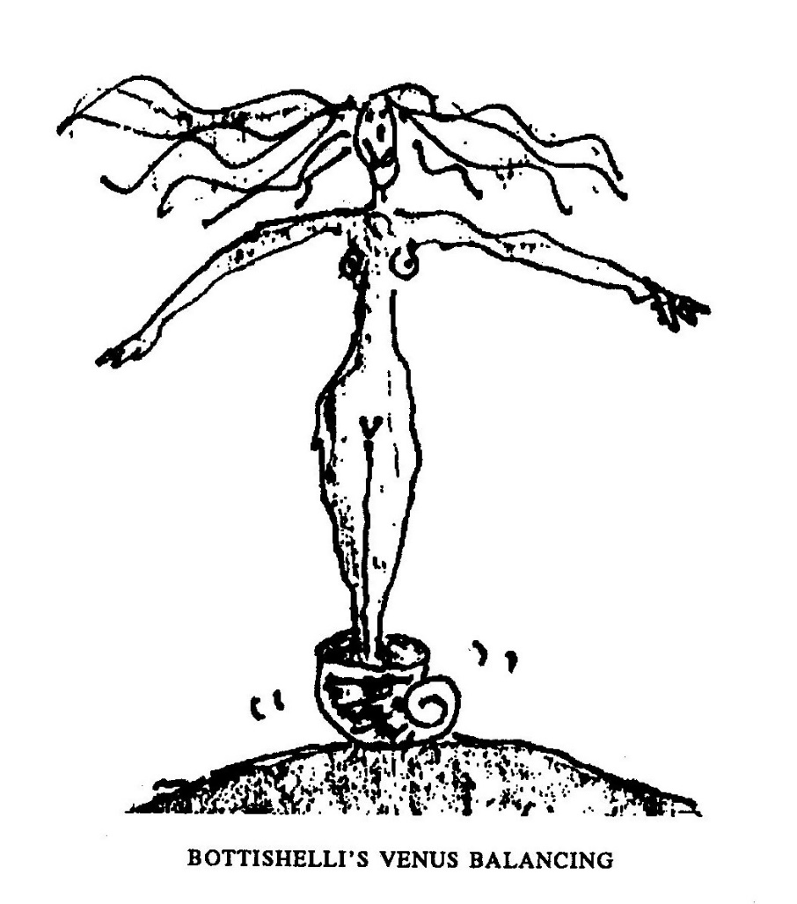
The bell rings louder now:

Fibonacci's Constant —
The length divided by
The height of the facade
Of the Parthenon. A
Golden Thread — connecting
The Athenians to
Pacioli, da Vinci,
Kepler, Corbusier.
The Divine Proportion -
Determining the growth
Of plant, the shape of shell
And spiral nebulum.

Her mother, still driven by
The tried imperatives of
Trade, incidentally
Found new business for

The useful Golden Mean.
Modern Miracle

Manna did descend again. It fell, as soft as dandruff, for a few
seconds at four in the afternoon on an Edgemead garden on
the 3rd April 1984.
Mrs Emilia Steenkamp was standing on her lawn and held
up her hand to interrupt the drifting cascade.
”I was on a diet at the time," she said, “So I didn't taste it.
But I knew what it was. The feeling of it tickling my palm was
wonderful. I felt all young again and spent the rest of the
afternoon laughing and crying.
“By the time my husband came home all trace of it was gone.
Vanished completely. We think the ants walked away with it.”
Doctor Ben van Vlaanderen of the Parow Paraphysical Re-
search Unit was hesitant to comment: "Unfortunately, with
the disappearance of the evidence we are
not in a position to authenticate the
mannafestation.
“Moses and others had it
much easier. In those days
the supernatural was not
subject to scientific
scrutiny and
believing was
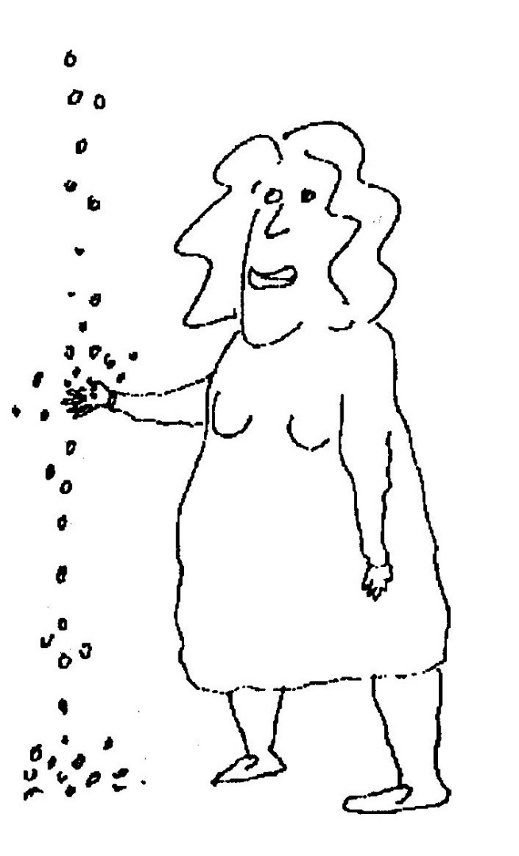
definitely
seeing."

Snail Atman

O simple snail upon yon leaf,
Eschewing joy, eschewing grief:

The karmic round of mortal men,
Of birth and death and birth again,
Does not, I think, apply to thee
Who art beyond mortality.

O transcendental monoped
Why, you are neither quick nor dead.

Conjunction

Me&ering along the str&
(&ante, stepping, sarab&)
Where littorally sea joins l&
I spied, engraved upon the s&
A perfect, snaildrawn ampers&

Omward Bound

Oh simple is the holy man,
Unfettered does he roam
With sandals, stave and begging bowl
While chanting: ”Om Sweet Om”.

On First Creeping into a Poem by Dylan Thomas

I might be slime and calcite shale,
The common stuff of man and snail,
But yet my consciousness is pure.

One principle I know for sure:
The force that curls my spiral shell
Unwinds the universe as well.

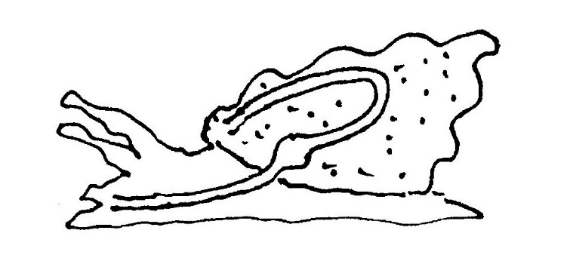

Why Snails are Vegetarian

I must watch what I eat,
the mollusc said,
because my bum is just
above my head.

Such alimentary expedience
is a plain public inconvenience.

Nostalgia for the Truth

Young Jessica set out to prove
That snails, although they slowly move,
Have a distinct
Homing instinct.

Slakkie and Simon Snail were sent
As part of the experiment
By bus and air
To Inkumba in Zaire.

Each had a tag upon his shell
But not a hope in hell
In a snail’s life
Of getting back to kids and wife.

Said Simon to Slakkie ”It’s sad that less
Will never know of her success
I know that it's futile to try —
But still I pine for Plumstead’s sky.”

The Amoeba is Immortal

The Universe eternally
Envelopes death and life;
Both trouble and tranquillity,
Harmony and strife.

It drifts through lonely nothingness
(With pulse and pulse and glide)
Its glowing, throbbing nucleus
just itching to divide.

It has but one imperative.
One law in its Torah:
A schizoid urge to generate
Its own diaspora.

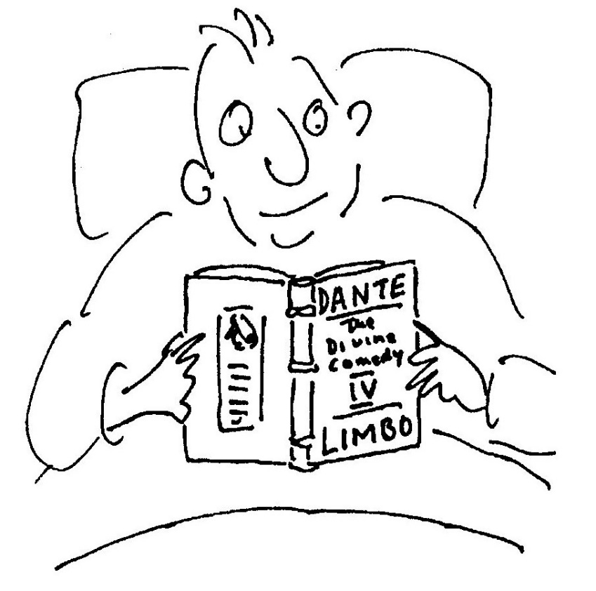

Justification

Life is a gift of time
Spent in gathering evidence
Against a summons for the crime
Of wasting that inheritance.

Maslow was Wrong

—for the Tilani

Along an early morning lane
Between the forest and the sea
A hundred iridescent webs
Are laid like nets upon the lea.

Roughspun, they look like gossamer rags
Or even gleaming dinner plates.
And at each rim, alert, polite,
A bright, attendant spider waits.

The threads though tacky to the touch
Remain quite empty through the day,
Except for shimmering drops of dew.
A clue? Perhaps the spiders’ prey

Is not small creatures dead or wrapped
But starlight, luminously trapped?

Sailing Alone Around the World

—for Lauren

In Cape Town many years ago
There lived a snail called Dallio.
’Though slow as often molluscs are
He yearned and burned to travel far.

He had no kids, he had no wife
And travelled all his livelong life.
His meals he took while on the hoof,
His shell, a backpack and a roof.

He tacked in six years all the way
From Rocklands Beach to Bantry Bay.
Long-suffering, with motives pure,
He learned, while living, to endure.

Then, on his death, his soul was told:
”Obsessive snail, since you were bold,
The doughtiest of all your nation,
You can choose your re-incarnation.”

”Ironical,” old Dallio said,
“Alive I had no choice, but dead
An option looms, I'll be a man,
A great explorer if I can,

And circumnavigate the Earth.
Around its plumply massive girth
I'll sail, alone, by night and day
Through wave and wind, in storm and spray

In a solo sloop of wood and oakum.
And can I be called, please, Joshua Slocum?”

Footnote: Coincidentally a certain Joshua Slocum did sail his sloop,
the ‘Spray’, alone around the world and in 1900 published a book
about it, which has the same title as this poem.

The Walls of Redwing

Intoning poems at a school
I donned an academic cool
And held the whole of Standard Three
Attentively transfixed by me.
The spacious hall had windows high,
Blue gothic fragments of the sky,

While at my feet the children sat
Enrapt, an all-absorbing mat.
I mentioned love. I spoke of death
And resurrection in one breath.
I read from Blake. I read from Frost.
I waxed profound. The kids got lost.

With thrash of wings and raucous din,
Two‘ starlings flew from outside in.
Like drunken bats, about the hall
They ricochetted from wall to wall
And bumped and slapped and bumped again
With wing and beak each window pane.

The face of every girl and boy
Evolved from torpor into joy.
And then, as sudden as before
They ﬂed (Assassins!) through the door
To toss without aesthetic care
Another burlesque through the air.

Businessmen in Flight

In motion thirty thousand feet above
The ground, like sardines in a streamlined
We arc the earth with pinion and fin
Intent on missions mercantile. The love
Of ﬂight, the sheer suspense of disbelief,
The graceful gravity-defeating act
(An arabesque of faith), does not, in fact,
Excite the pulse, cause ecstasy or grief.
We who travel, but not for travel’s sake,
Are ﬂung aloft by market forces, still,
Take pride, while cloistered in an aerobus,
That Marco Polo, Mungo Park and Drake,
Explorers who escaped the common mill,
All represented merchants. (Just like us!)

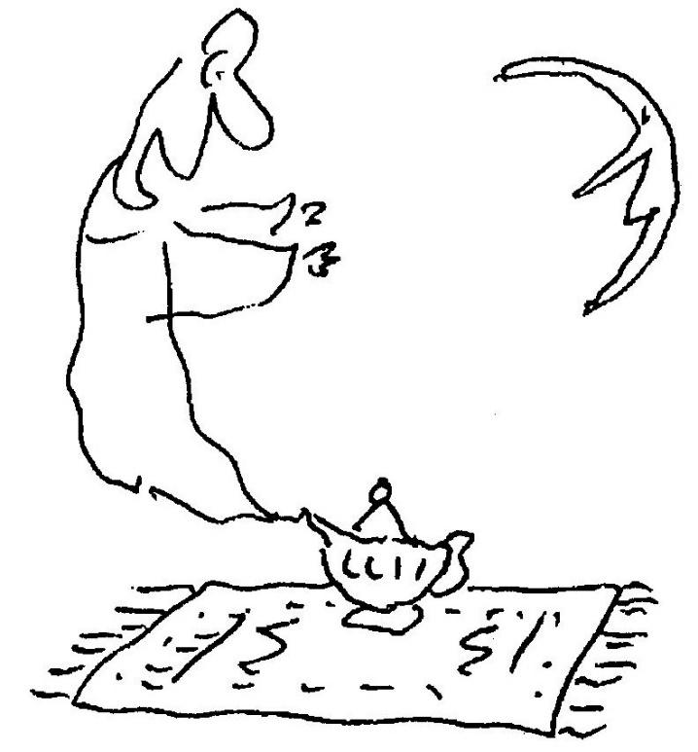
Innocent Experience

An ageing sheep
Who was quite deep
Read Blake and cried:
“For goodness sake!

If Christ is shepherd
And Christ is lamb
Then half—divine
Is what I am."

And then she sighed:
”Not true, because
Half-divine
Is what I was!”

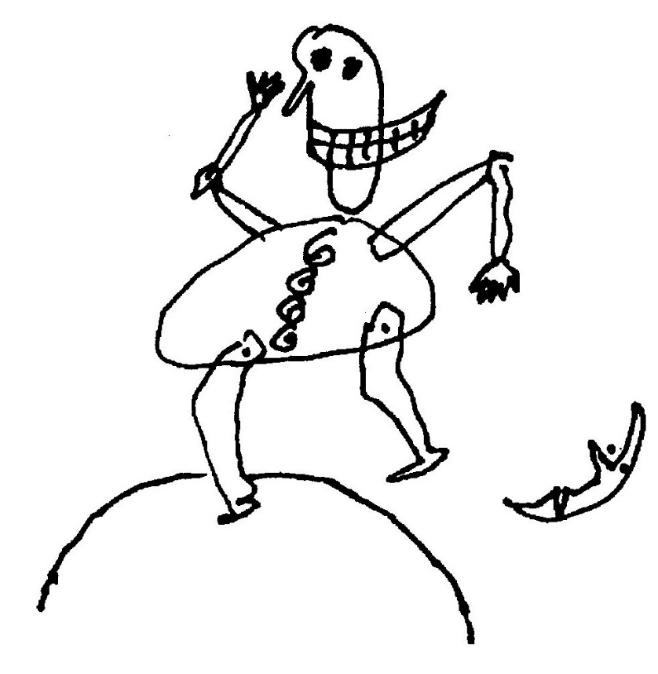

Thirteen Haiku

1
Tired of book and tract
And thesis, I turn to life
For exegesis.

2
—A Dialogue Proving God's Existence
”Look how perfectly
That small chameleon there
Is camouflaged!” “Where?”

3
The rain, when it pours,
Beats through the trees like discreet
Japanese applause.

4
Just the briefest glimpse;
Then all eternity for
Interpretation.

5
In a single star
Hotel, a bedside lamp sheds
Light on the Bible.

6
—-from Matthew
Lots of people in
Plumstead, Dad, play pianos
At night — it's lank sad.

7
—Astigmatism
How wonderful to
Age: Two moons and a double
Plenitude of stars.

8
We paid sixpence (it
Was a lot then) to see the
Invisible man.

9
Wooden poles support
The vines. The dead and
Living intertwined.

10
Die verre sterre
Wink. Die kosmos is beslis
Immer en bewus.

11
—Panic
Eight '0 clock; the cars
How urgently they rush to
Reach the traffic jam

12
—]oburg
On cold crystal nights
A galaxy of grounded stars —
The city lights.

13
Out of the harbour,
A little effort, a few
Waves — the land is lost.

Yet in Arcadia Ego

I strain against the southeast gale
My futile shirt a ﬂapping sail.
The vineyards and the waving grass
Applauding wildly as I pass.

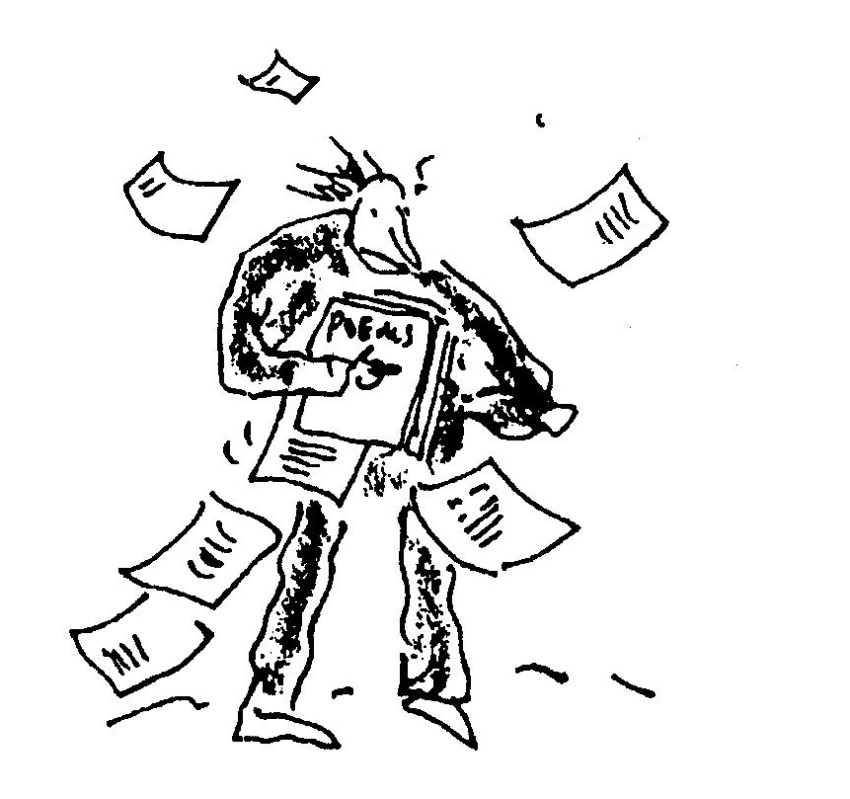

Midlife Crisis
or: Plato's Cave Again Revisited

Transfixed, I stand
upon the stair at work and watch,
reﬂected in
the foyer mirror,
etched silhouettes of children, shadowed
on a sun-bleached
wall, careering
off to school.

Twenty Questions

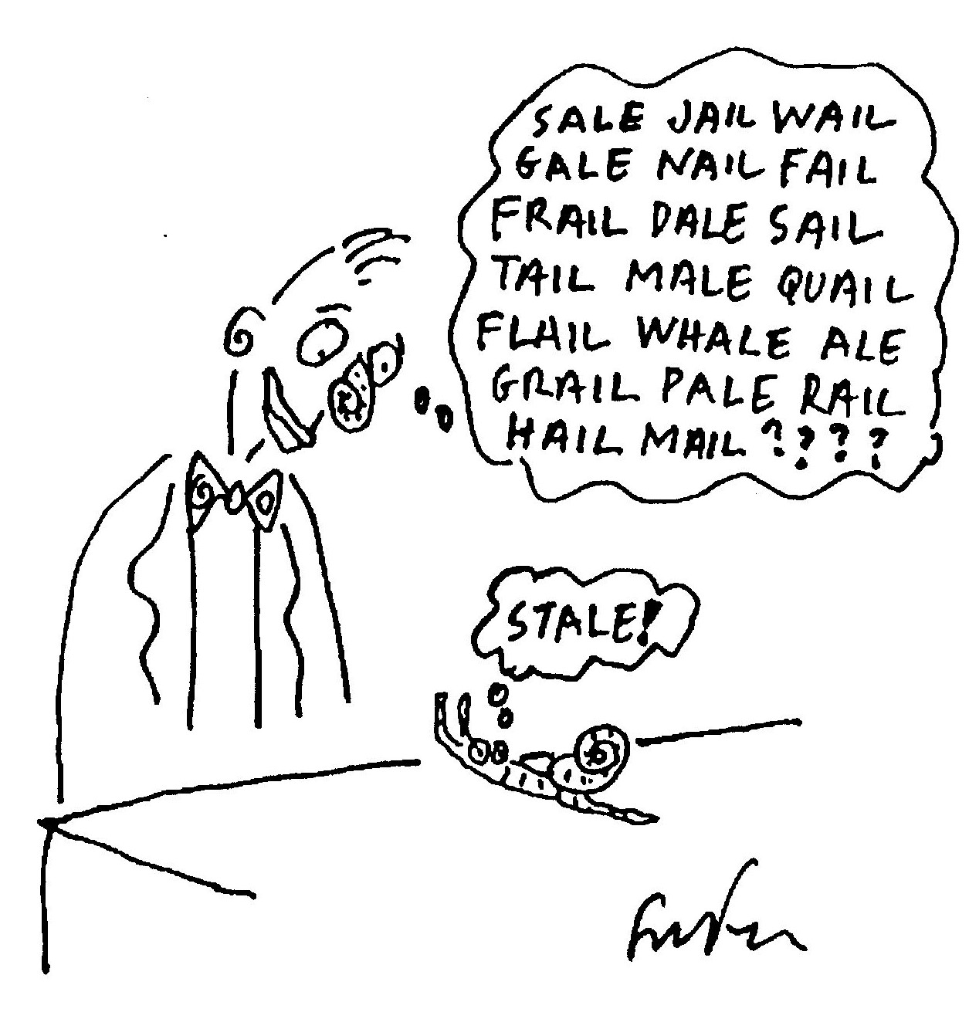

Mightier than the Sword

Vainglorious were those distant days
When poets sang and laid their lays
Like egglets in a barren nest —
When Honour was Man's pluméd crest.

Full many stories have been told
Of heroes pure and heroes bold
Who cut and thrust their way to fame
And are beyond both fear and blame.

But minstrels seldom eulogise
The pusillanimous or wise
Or those who look but never leap,
Whose scythes are much too blunt to reap

So I intend to fill the breach
And tell what myth will never teach,
Which is in short: Man's at his best
When he disdains to meet a test.

Preamble done. Now hear the truth
About a youth extremely ruth
And fey, who nonetheless did dare
To woo a maiden wondrous fair.

His name was Jack, his calling, clerk.
He feared the sun, he feared the dark.
He loved reflective ponds and shade.
He spurned the mountains, sought the glade

And yet, he loved sweet Emily
With passion wild, and she loved he.
But now the pace begins to quicken,
Now the plot begins to thicken:

Sweet Emma had another beau;
The arrogant Lord Aristo,
A scion of the Duke of Gru,
A sportsman and a soldier too

Who had that popularity
That stems from power and fealty
And breeds insensitivity.
Although he too loved Emily

(How many ways can love be blind?)
It never ever crossed his mind
That she, of independent whim,
Could want a man that was not him.

For lovely graceful Emily
Adored the clerk, Jack, fervently.
He took her to his secret glade,
To show her eggs by plovers laid.

He made her laugh with silly puns
But never spoke of swords or guns
Or even mentioned Honour once.
One day, he asked her to a dance

And in delight she cried out: “Yes!”
Immediately planned a dress
The colour of the plover's egg
To pull her gentle lover's leg.

The next day Em received a note
From Lord Aristo — I quote:
"Your presence hereby I request
At the Ball. You'll be my guest.”

This brief reply she sent right back:
“So sorry, but I go with Jack.”
Aristo swirled into a rage —
He smashed a mirror, smacked a page

And swore dire vengeance on the clerk
Who'd wooed his Emma like a lark
And not a hawk. A second note:
This time to Jack. Again I quote:

"If you, Sir, are indeed a man
I will believe it if you can
Appear at dawn upon the heath
And fight for Emma unto death.

”The bearer of this note you read
Will second me. If you've agreed.
Please tell me yours and set the day
Before the Ball (a week away).

”And, by the way, our duelling laws
Decree the choice of weapon yours.”
Jack read the brief with vision blurred
His heart was beating like a bird

Imprisoned in a cage of steel.
The one emotion he could feel
Was wobbly, undiluted fear
Of death, inevitably near.

Because, despite his funk he knew
His Em would not be Lady Gru,
But just the thought of Aristo
Caused his legs to rubber go.

He had no skill with sword or gun,
What use in battle is a pun?
Reluctant to capitulate
He spent each day in morbid state.

And tossed and turned each night in bed
Enacting death-scenes in his head.
He mentioned nought of this to Em
Who busy was with tuck and hem.

Poor Jack thought wryly: ”Let me guess —
A funeral or a bridal dress?”
The deadline loomed. Denied of rest
Jack wandered to the plover’s nest.

The mother scuttled in alarm
But Jack the Gentle meant no harm.
He gazed in wonder at the shell,
Calm contrast to his inner Hell.

When, suddenly, its surface cracked
And spoiled the perfect artefact.
And with a tiny tick, tick, tick
Emerged a bald and bleary chick.

Unarmed and vulnerable?!
”Good grief!” thought Jack, ”I’m just like you,
But you are bright with cheerful cheek —
You are the paradigm I seek."

He rushed back home relieved and gay,
Exclaiming: ”Wit will win the day!”
Grabbed pen and ink (dispelled was fright)
And confident, began to write:

"Dear Aristo, young Lord of Gru,
I will with pleasure meet with you.
My second is my bosom pal,
The mandolinist, Diji Tal.

”I leave to you the choice of day,
It matters not. And, by the way,
You know, of course, my skill at arms
Is not the champion of my charms.

”But I, through fear, have found a plan
That will decide the better man:
The loser now will win the bride:
Our weapons shall be suicide.”

Call and Response

Too much has already been said
About the domestic cricket's
Grave, funereal demeanour;

Too many words have circumscribed
His stridulating, pulsing shriek
That beat the electronic bell

By some three hundred million years
But early man, hunched at his
Palaolithic hearth, had no

Pre-Pavlovian reﬂex arc
Compelling him to clap a lamb-
Bone to temple and cry: ”Hello?”

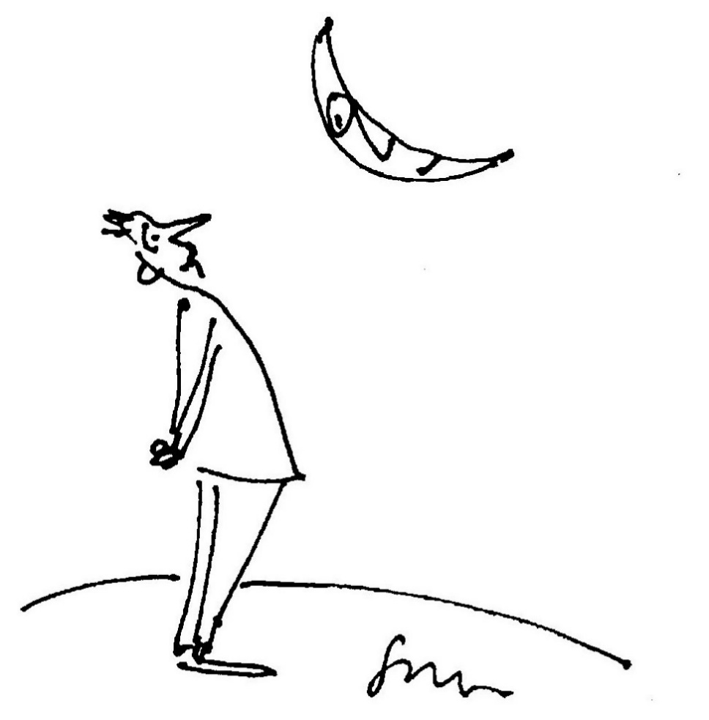

Tending to Eden

The gardener’s extremely slow,
A dull, procrastinating drone,
Who weeds less quick than weeds can grow

He hesitates to prune or mow;
The garden's getting overgrown
The gardener’s extremely slow,

His productivity is low.
He seeks no help, but works alone
And weeds less quick than weeds can grow.

He hunts for snails with brandished hoe
Upon a lawn that's still unmown,
The gardener’s extremely slow

And is an ineffectual foe,
In spring-time seeds are never sown.
He weeds less quick than weeds can grow.

He has the wisest slogan, though:
”Leave well and well enough alone!”
The gardener’s extremely slow
Who weeds less quick than weeds can grow
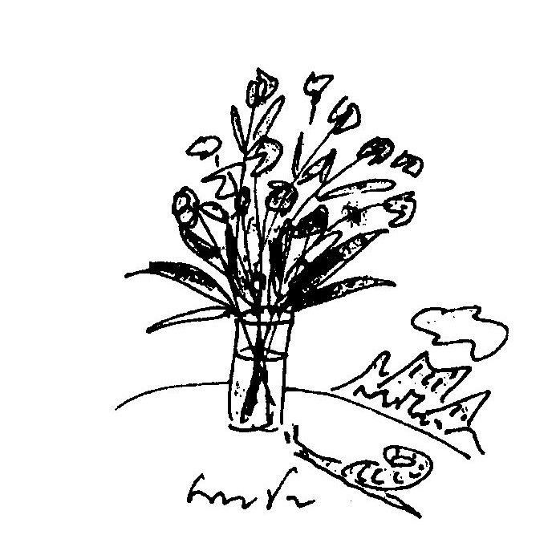

Fugue for Rhythm and Wind

The poplar and plane;
Kinetical trees
That shimmer and shift
Through doppler degrees.

Leaf, light and wind
Weave a contrapuntal ruckus
That immediately brings to mind
Both Mozart and Maracas.

Two Reggae Rhymes for David

1
O elegantly rasta palm
Skanking in the air
Tossing in the north-west wind
Your natty dreadlock hair.

2
O little star aster far
I wonder at your sheen
Changing like a traffic light
From red to yellow to green.

O little star aster far
I wonder if you are the
Celestial resting place
Of Robert Nesta Marley.
M C Koei

A hippopotamister
Had a hippopotasister
Who was liberated in the style
Still popular in the Upper Nile.

It riled this hippopotafeminist
If, in passing, she was missed
or missused
By a male hippopotachauvinist.

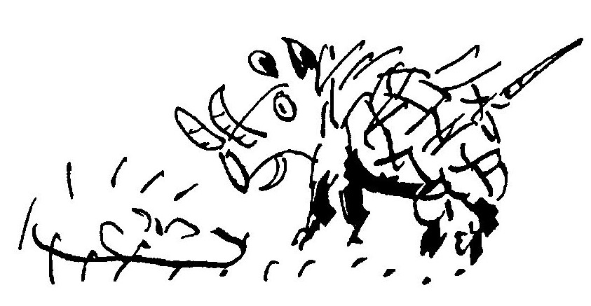
Then she would incisively insist
On her non-sexist, proper title,
viz:
HippopotaMs.

Narcissus

The warthog at the waterhole,
Transfixed in’ sheer delight.

His image in the murky pool:
A mesmerising sight.

The starlings at the birdbath preen
A slug slides up the pane.

The beautiful are not alone —
The plain are also vain.
Death on the Road

It crept across the country road,
the snake that made us stop,
In threat it raised its spade-shaped head
and puffed its body up.

We all moved back in mild alarm,
an atavistic fear;
Deep down we knew what Adam felt,
when Satan sidled near.

But that was that. We checked no urge
to hurt or kill the beast
(This tale is not Lawrentian,
nor moral in the least).

In fact, our one concern was that
the snake, now lying still,
Might soon be squashed by truck or car
(we wished this snake no ill).

We lamely tried to shoo it on
but still it doggo lay
And none of us would pick it up,
a fact we'd rue all day.

We cycled on, all hoping that
our friend would slither fast
Across warm tarmacadam to
the safety of the grass.

"I've heard,” said Nick, ”that snakes enjoy
relaxing in the street.
The tar retains the sunlight well
and reptiles need the heat."

We pondered on this thought a bit,
imagined how it feels
When, hurtling through the morning air
came Death on sixteen wheels.

There was no chance it could escape
such synchronistic fate,
When we returned five minutes on
We were five minutes late.

Our erstwhile undulating friend
obliterated lay.
A tattered rag. The grassy verge
One million miles away.

And then we knew that our concern,
our gentle empathy,
Had slowed it down so it could keep
its date with destiny.

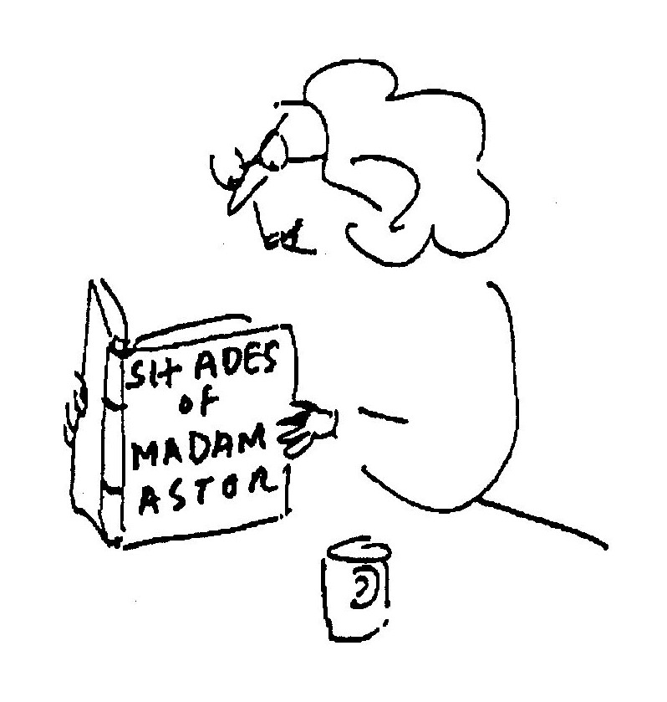

The Armageddon Trail

The fag end of a tiring day
In which we had to trudge
Across vast tracts of active waste
Through swamps of plastic sludge:

We came upon a citadel
On top of several hills,
A glowing thrum of factories,
Of power-plants and mills

Expending steam and curling smoke
That billowed up in shrouds.
My daughter gasped: Is this the place
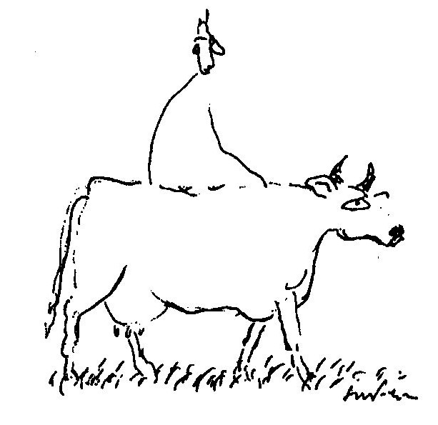
Where God makes all the clouds?

(No)Thing

That's me you see aboard a cow
Travelling through the here and now
I ask her gently: “Is it true
That cows have Buddha nature too?"
She ruminates and answers: “Mu!”

Life Sentence

Ionathan Plaatjies
Who was born in the remote Cape Hamlet
Omdraaispad which is known for a statue
Of one of its postmasters Ian de Klerk
Representing him holding a limp fish
In an outstretched palm which was erected
In Nineteen-nineteen in his memory
By his eccentric wife Tamara who
Later scandalised Genadendal by
Living in sin with the Persian painter
Omar Barry (there were some who said he
was not Persian) who invented Karoo
Cubism by meditating on the
Rock formations in the Bamboesbergen
Died today.

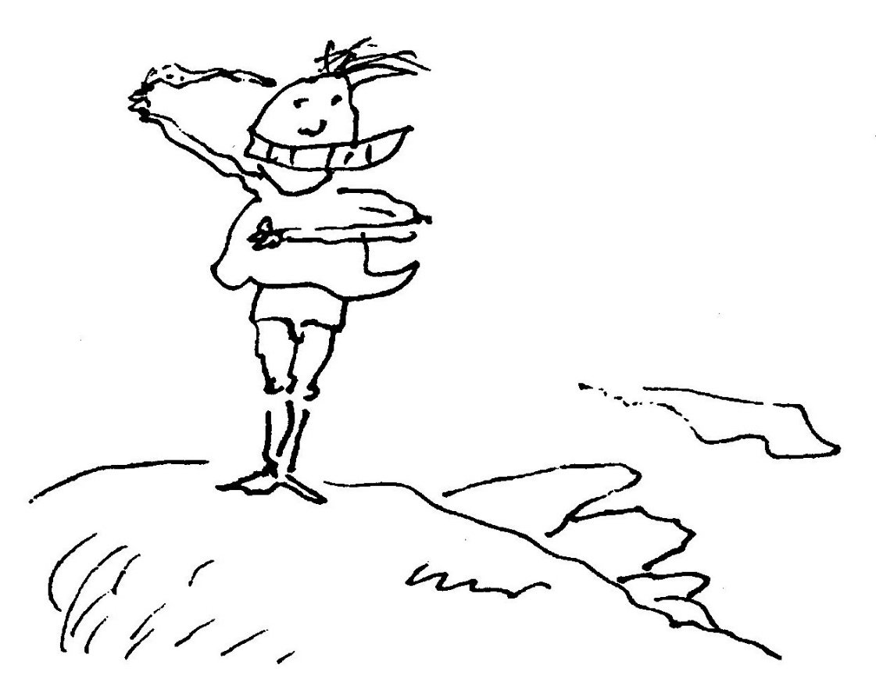
Bill MacFeather

The cruellest man that ever was,
His name was Bill MacFeather,
Two goldfish placed, in different bowls,
And pushed them close together.

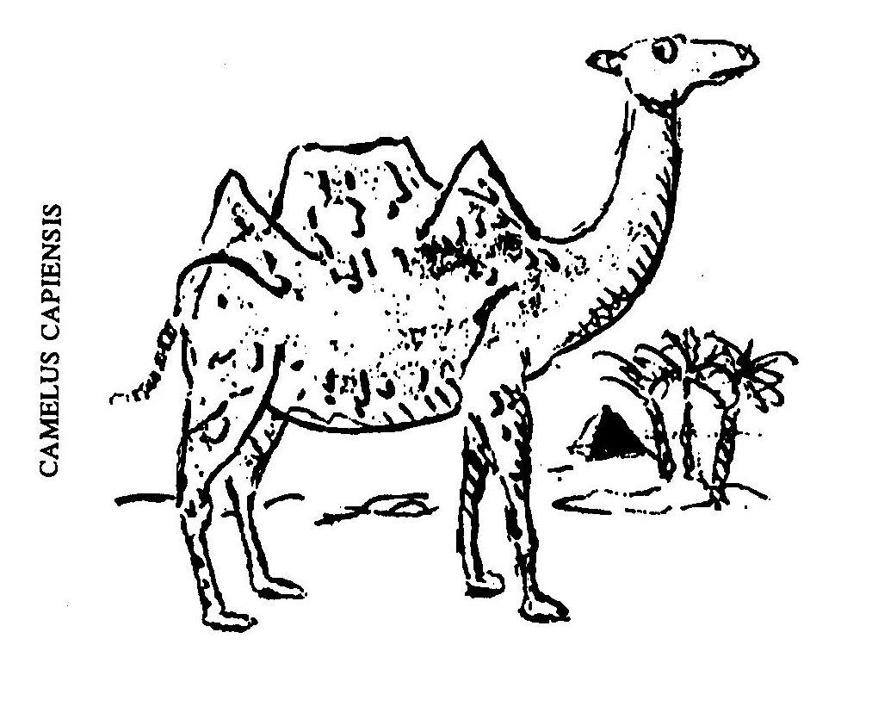

Matthew Farnham

The sweetest man that ever was
(His name was Matthew Farnham)
Smeared Novocaine upon his socks
Before he tried to darn them.

RA in Bow

The stone pyramids of ancient Egypt are opaque facsimiles of
a far older and more mysterious structure identical in dimen-
sion to the famous pyramid at Cheops.
The fabled Pyramid of Ra (Re), named after the sun god, was
a precise prism of solid glass built on the right bank of the Nile
at Heliopolis. According to Papyrus records, a giant concave
mirror made of burnished bronze was placed about a mile
away and was used to focus an intensified beam of sunlight
through one of the prism walls. Refraction through this grace-
fully translucent pyramid produced the most glorious of
rainbows.
The site of the pyramid was held sacred for the Akira festi-
val, which celebrated the evanescence of life. The poet, Pindar,
is said to have been inspired by legendary accounts of the
prism of Ra:

A dream of a shadow is man
And yet
When a glory of light comes over him
His life is sweet.

Tragically, the pyramid was shattered by a broadside from the
eighty-gun Portuguese man-o’-war, the Sombramort, which
sailed down the Nile on a raiding sortie in 1514, during the
Ottoman Empire. The myriad fragments, each rumoured to be
a minute prism, have been dispersed over the centuries by the
sirocco of human commerce.
There remains only a linguistic trace. The English word,
‘rainbow’, may derive from the Aramaic phrase, ”Re anbahr",
which means ”God is light."
Hinault's Not What He's Missing

—for Lee

I love to ride my bicycle.
I love to keep in shape.
I skim along the country roads
On all-fours like an ape.

Though clouds above are scudding
And the roadside hums with life,
To me it's just a canvas that
I cut through like a knife.

My posture’s parabolic as
My feet pump up and down
And all I see while training is
A tyre turning round.

An optional moral
I am, you'll note, in every way
A man like all the rest:
Oblivious to life itself -
Preparing for a test.

Book Club

My tame, domesticated wife
Tugs slightly at the strings of life
When, once a month, she ﬂies the coop
To join a book discussion group.

No men allowed! This silly rule
I think is chauvinist and cruel.
”Who needs," I shrug in my defence,
"Their gossip laced with Lit Pretence?"

But when it is her time to host
It's then it irritates the most.
Ignored! My fragile ego scarred!
A writer scorned! A poet barred!

I prowl the house, aloof and numb
But furtively, each time, succumb.
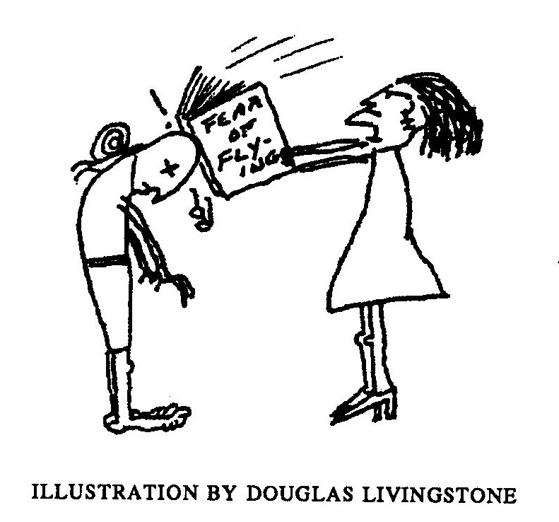
Against the door I lay an ear
And don a patronising sneer.

The moral is: What men deride
Is that of which they are outside.

Blessed are the Meek

Oh what can ail thee, Snail at Arms,
Alone and palely loitering?
The sedge has withered from the lake
And no birds sing.

In vain I've wandered far and wide
In search of any living thing.
The plains are sere, the trees are gone
And no birds sing.

The silence is a winding sheet
That shrouds the planet, grey and dry,
And none appears to be alive
Save thee and I.

The holocaust has come and been
When crackling ions filled the air,
When burning rain and sickly death
Were everywhere.

Then I, like all my kith and kin,
Did batten down my fallout shell
And in my calcite casing lay
Both safe and well.

But aeons passed, it seemed to me,
And restless have I been of late
And dreadful driven by desire
To seek a mate.

Ah verily, the angel sighed,
The first survivor have I found!
And then he blew upon a conch
A curling sound.

From all around, from cran and nook,
Small stones transmogrified to snail
Who crept to hear, with antlers out,
The angel's tale.

The winged one scattered seeds about
And up sprung lettuce, shrub and grass
Great news! he cried, A Prophecy
Has come to pass.

By your manner mild and modest
You have entirely proved your worth
The Lord has designated thee
Inheritors of Earth.
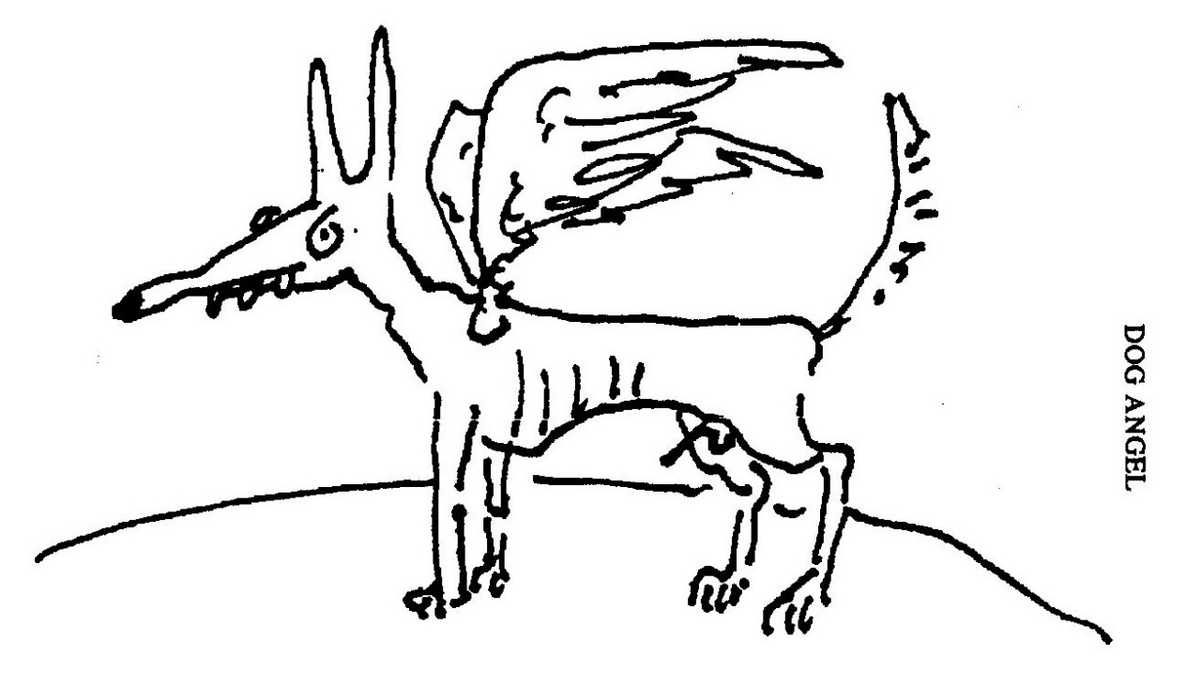

Up and Up Mount Everest

A snail crawled up the window pane
Across the plane, reﬂecting blue.
A trip that seemed to be in vain.
I asked, ”Where are you travelling to?

"You heave against steep gravity
Away from shelter and from feed.
I am perplexed most grievously,
What spurs you on? What fear? What greed?"

The silence hushed my rhetoric.
The sherpa schlepped on limpidly,
Of carrot heedless and of stick
Quite unafraid. Its destiny

As clear in retrospect to me
As that of Edmund Hillary.
