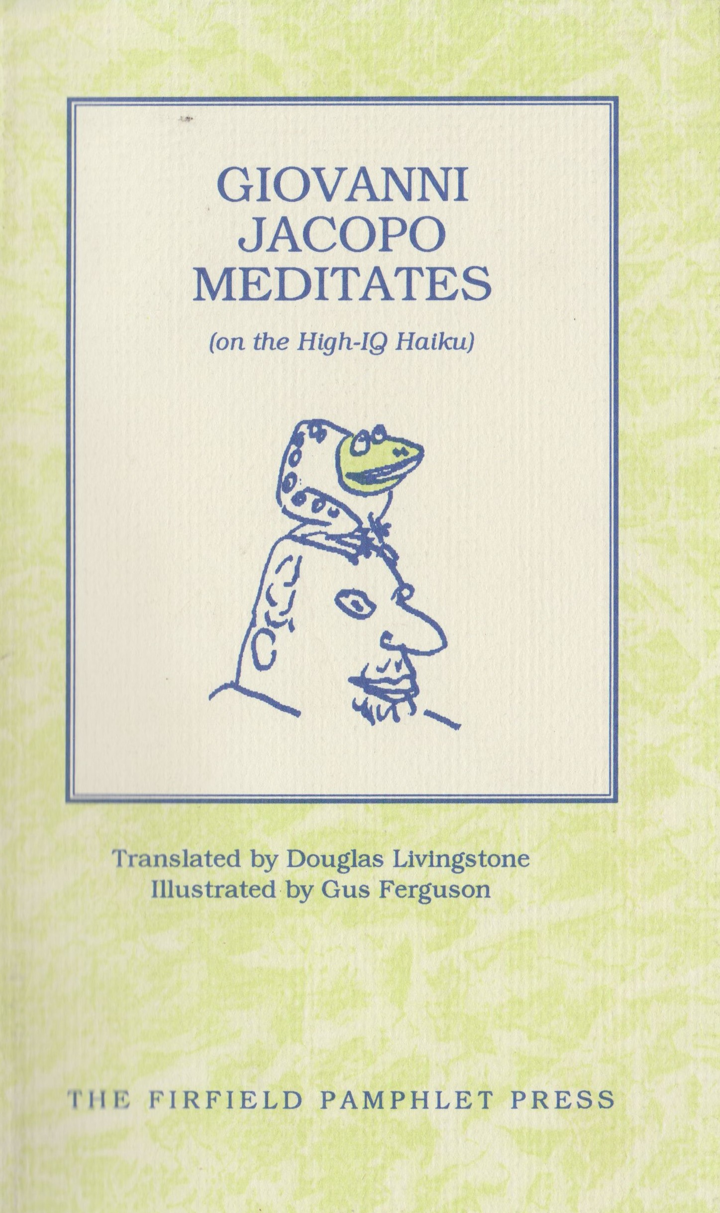
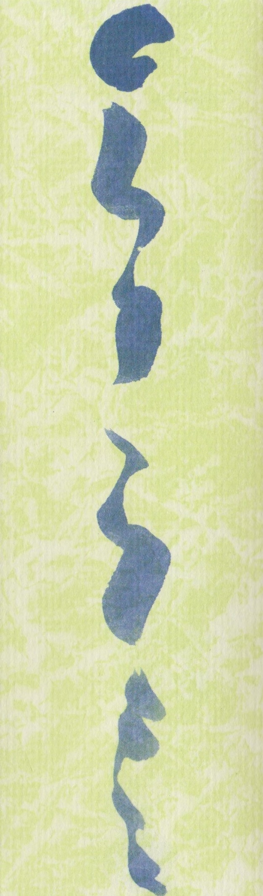
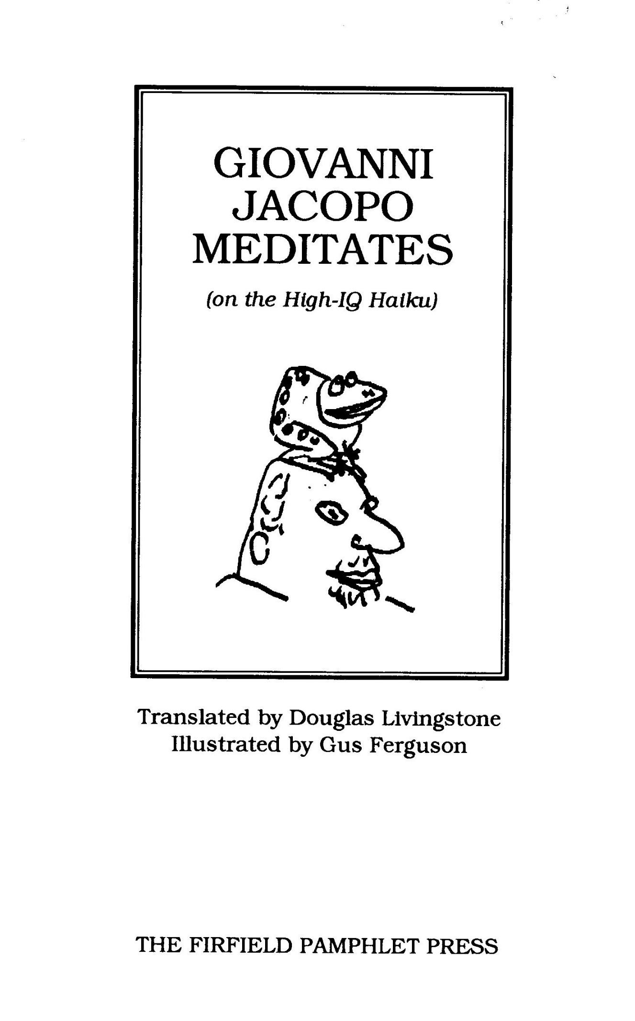

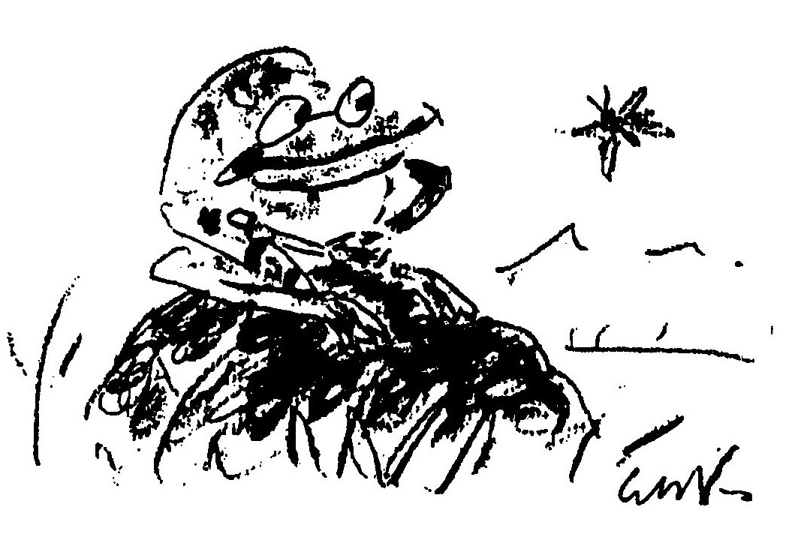

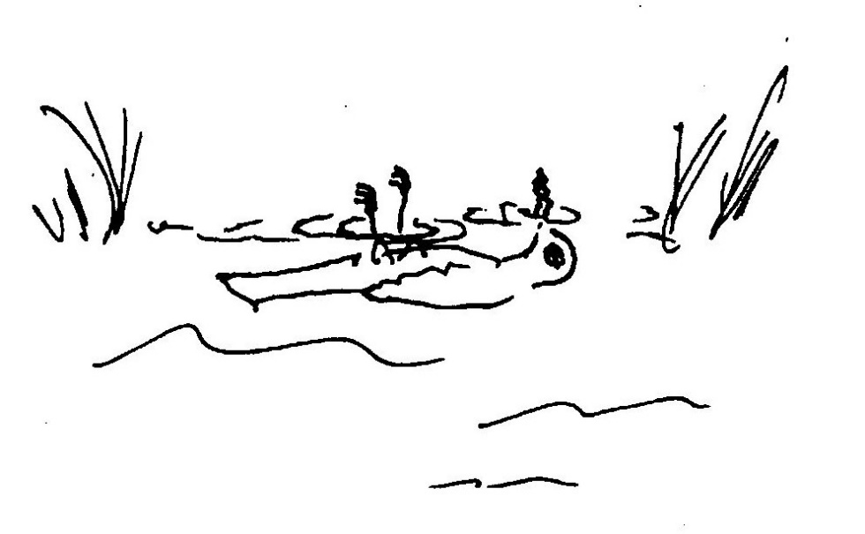

THE CORMORANT STRIKES
RIPPLES DISTURB THE SURFACE
WAIT NOT IT HAS DROWNED

THE COURTESAN’S FAN
THE TAX COLLECTORS DEMAND
THE FOOTPAD'S BLUDGEON

(VAR: 1)
AN ANCIENT FROG SINGS
KRAAK-KRAAK SPRING’S EARLY THIS YEAR
FROGS ARE QUITE STUPID

(VAR:2)
KRAAK-KRAAK SPRING’S EARLY
A FROG HYMNS THE NEW WARMTH
POETS PEE IN PONDS

REEDS DEFY THE WIND
HONEST POLITICIANS
OSTRICHES IN FLIGHT

THE SWALLOWS NEVER
CAME BACK TO CAPISTRANO
THE PASTA WAS OFF

THE SALMON RUSHES
UPSTREAM SMILES ETERNITY
& THE CAN NING WORKS

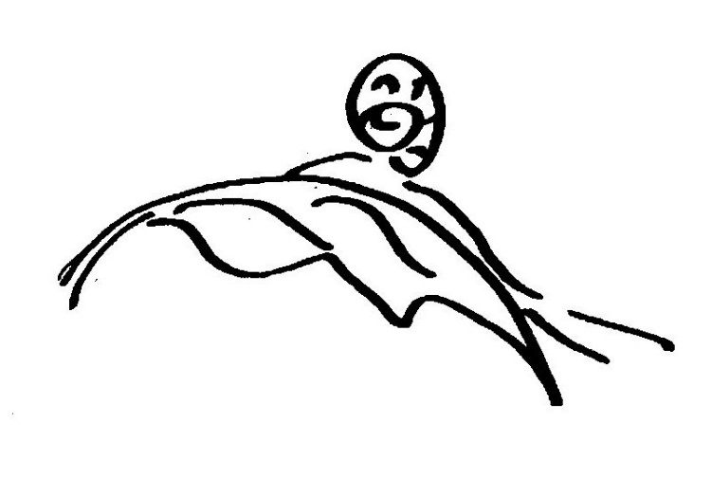
THE SNAIL MOVES SLOWLY
THE LEAF BOWS TO NEW WEIGHT
SPLAT GRAVITY RULES

FUNDAMENTALISTS
SO BUSY PROTECTING GOD
THREATENED GOD NEEDS THIS

THE FIRST MIRACLE
TRANSMUTING WATER TO WINE
GOT IT RIGHT FIRST TIME

PERCEIVING TWO MOONS
UNAWARE OF MIRACLES
THE DRUNKARD WEAVES HOME

LEGEND DROWNS LI PO
KISSING THE MOON ON A POND
DRUNKEN REFLECTION

PARED THIGHS OF HER SOUL
SUCH VULNERABILITY
THE NAPE OF HER NECK

BETTER A TIGER
FOR A DAY THAN A RABBIT
FOR SEVENTY YEARS

CENTURIES-OLD CARP
ICONOCLASTIC AN GLER
FRIED ICON & CHIPS

WHEN ASKED TO LISTEN
TO SOUNDS OF ONE HAND CLAPPING
SOMEONE HERE'S A FOOL

A TRANQUIL POND AS OLD AS SIN.
WHEN, SUDDENLY, A FROG JUMPS IN.
PLOP!

