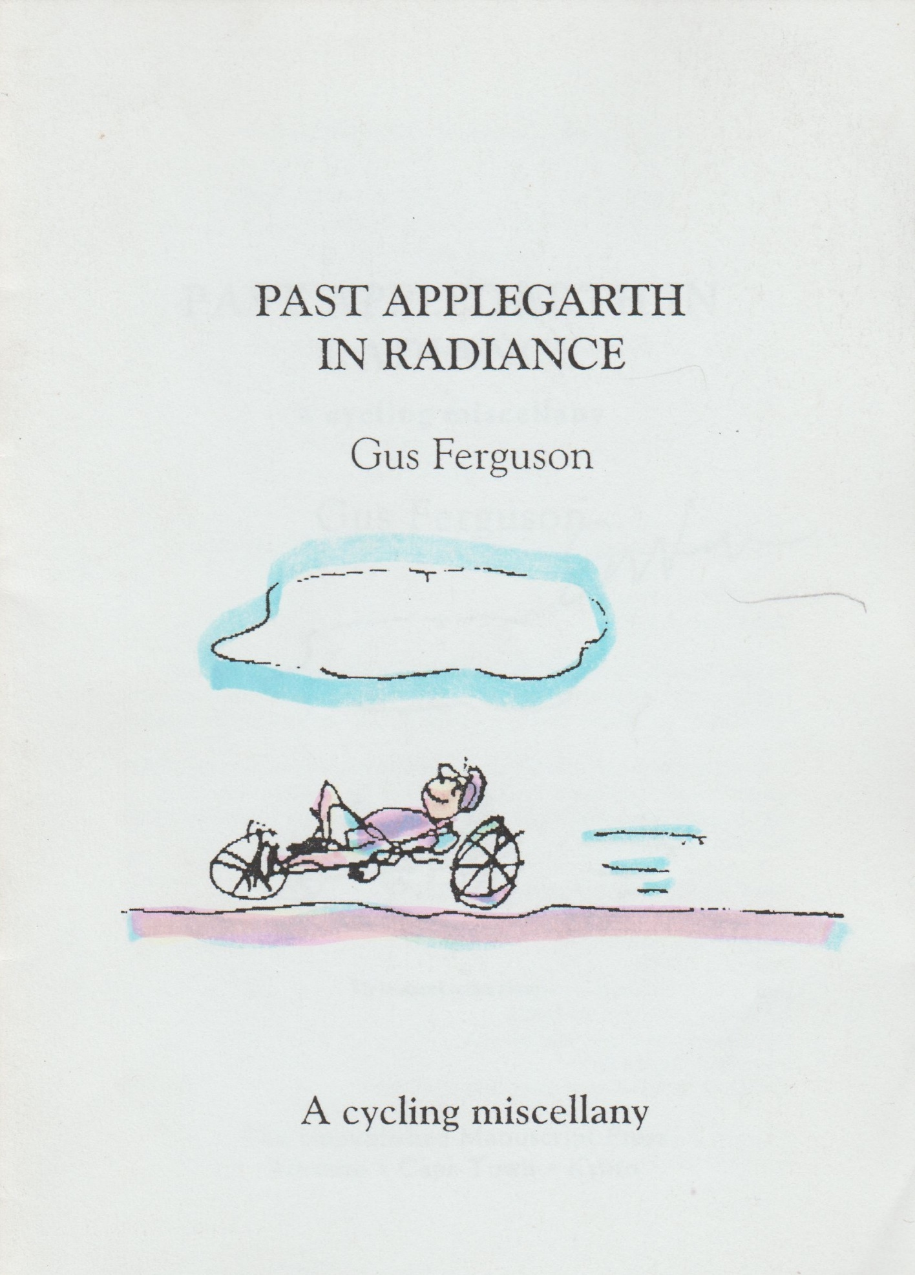

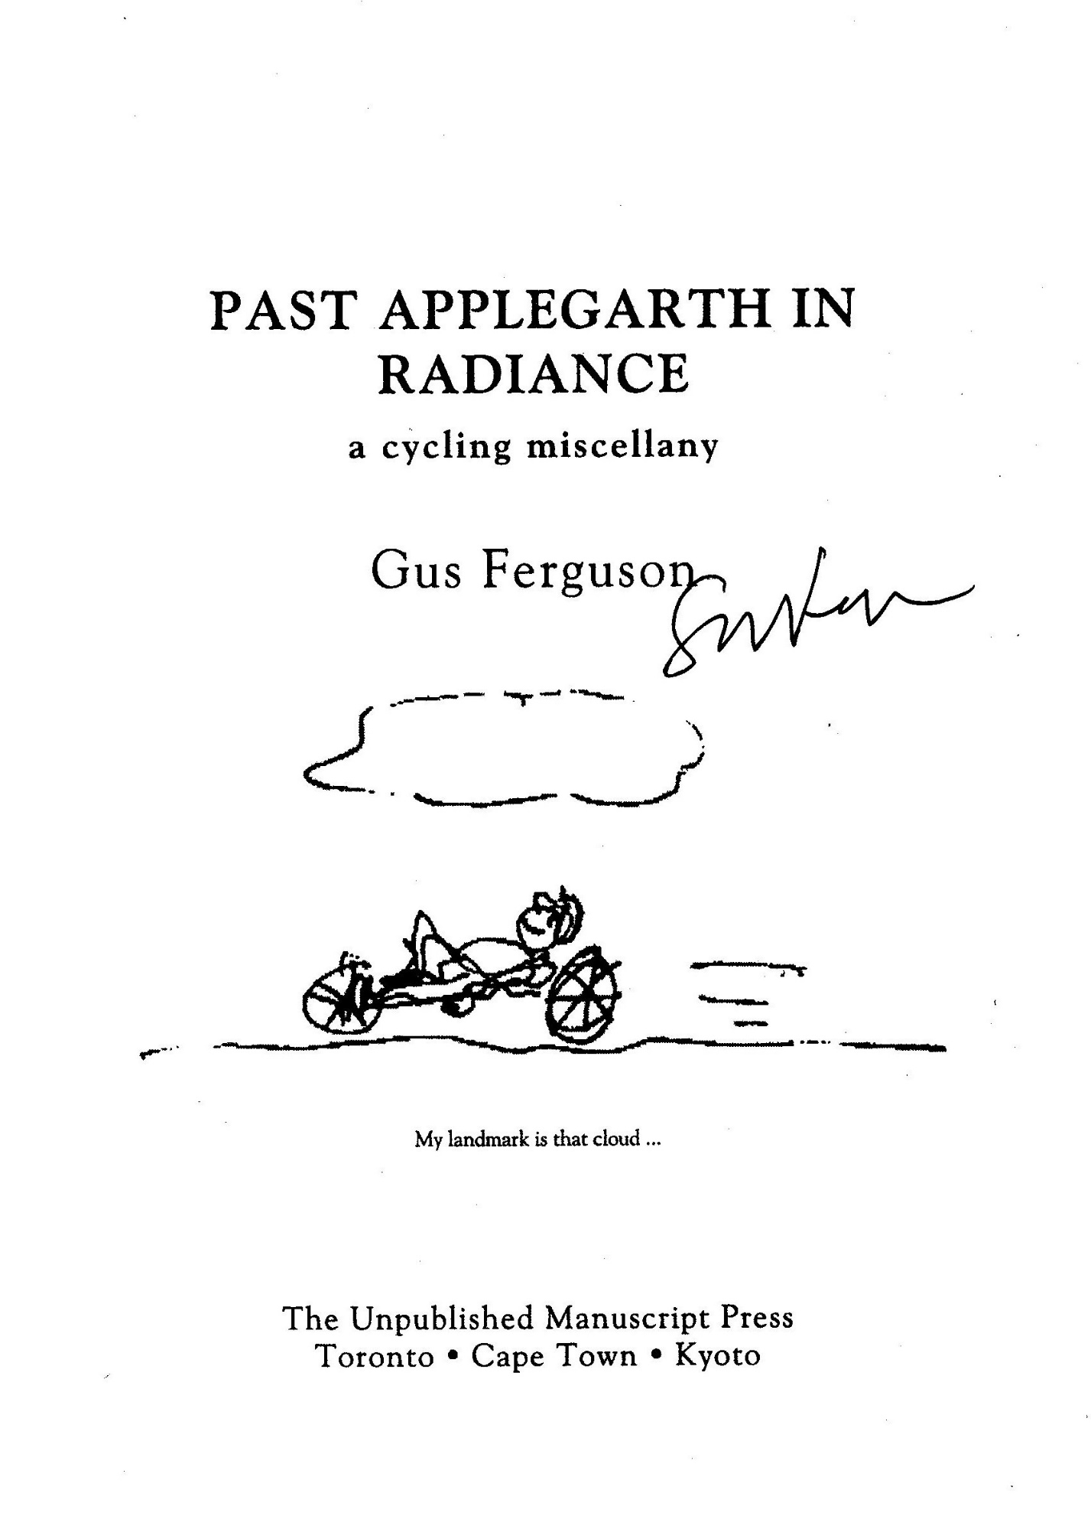

For all my cycling friends
but overridingly for
Lee Fox, role model, friend and mentor
and to Mary ]ane Reynolds who as editor of
Velocipede ﬁrst encouraged this nonsense

Past Applegarth In Radiance

My Sunday morning
Genuflections
Are made with bending knees
While sun spokes stroke
Across the road
And fire the fallen leaves.

My spinning chainwheel’s
Starred reﬂections
Whin upward through the trees
And glinting from
My streaming cold:
The snailtrails on my sleeves.

The Bhakti Yogi Buys A Bike

Astride my dual prayerwheel
I meditate at speed
Devotion to my Dharma is
The only call I heed.

I never lust for victory
Nor crave frenetic motion
But gentle like the Ganges
Flow calmly to the Ocean.

To cycle through the Cosmos is
A karmic task and thrill,
I just adjust my cadence to
The rhythm of each hill.

I have a little mantra that
I murmur on my way
And if you pay attention
You are sure to hear me say:

‘Though heavy is the Samsara.
And hard to pedal solo;
I do believe Eternity
Is fully Campagnolo.’

Cyclops

The dusk like gauze is falling
The day is fading fast
And homeward I am crawling
In hope that light will last.

As remnant shots of daylight
Are shuttled through night’s loom
I pedal apprehensive
Beneath the waxing gloom.

Myopic in the twilight
I peer from left to right
As cars from all directions
Scud blind towards the night.

Ecologists of the human race
List this amongst your theses:
That Cyclists of the Crepuscule
Are endangered as a species.

M’illumino d’immenso

near Llandudno

Alone, the swishing sound of spinning spokes
Disturbs the hush that marks the break of day.

In downhill speeding ecstasy we rush.
Below, the sea is opalescent grey.

Mysteriously, the low horizon drifts
And drops beyond the arc of human reach.

The ocean sighs and heaves in restive sleep
And snores incontinently on the beach.

A literary fugue begins to form:
The dreaming corpse in Finnegan's Wake

That etherised upon the table lies:
But soft, what light through yonder window breaks

But then, the voice of Ungaretti wins.
His matinal verse our day begins.

How Did Emily Pankhurst Get To Parliament?

l’ve seen those London bicycles
Especially in the rain
Who're rnanacled to railings
By principle and chain.

Buckled, rusting and deﬂated,
Their spokes are all awry:
So utterly abandoned,
A tear comes to the eye.

How are the British mores
That make them pamper pets
And then, neglect completely
These sainted suffragettes?

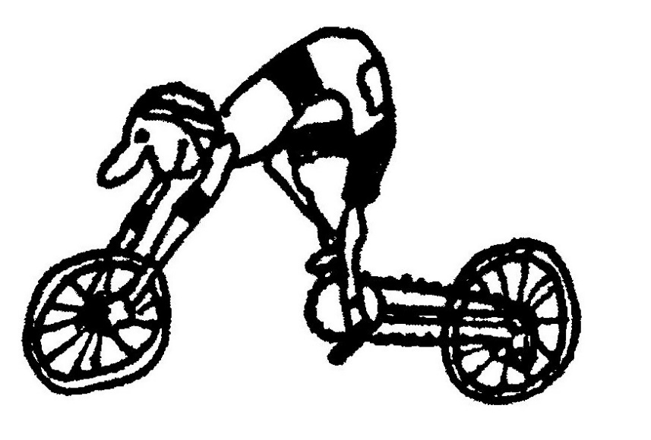
Puncture Near Wittedrif

What bliss to be alive this morn,
With land and lake awake to raucous dawn

And every instant serendipitous
I praise, head bowed, the moment I was born

And each unconscious step that led to this
Epiphany of pantheistic bliss

But revelation's brief: a single thom
Deflates it with a disillusioned hiss!

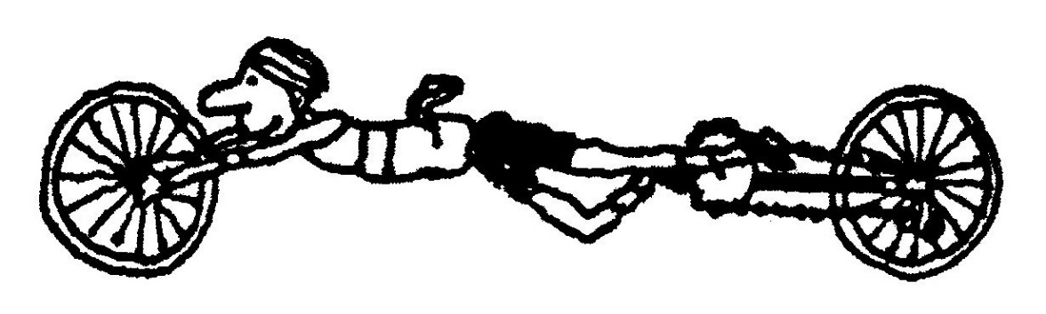

Illustrations: The Frameless Bicycle (pat pend) in action.
Note the ‘tubby’ in the back pocket which dates the idea
Yet In Arcadia Ego

I strain against the southeast gale
My futile shirt a ﬂapping sail.

The vineyards and the waving grass
Applauding wildly as I pass.

Limerick

A molluscular cyclist called Mel
Wore a crash-helmet made from a shell
He said: ‘It ﬁts right,
Looks nice and is light
And protects me from starlings as well.’

Puritan Against The Wind

When every pedal stroke's a bore
When bum and back and neck are sore

And ﬂesh is mortiﬁed for sure,
Then, I believe, my soul will soar.

Hinault’s Not What He’s Missing

I love to ride my bicycle.
I love to keep in shape.
I skim along the country roads
On all-fours like an ape.

Though clouds above are scudding
And the roadside hums with life,
To me it's just a canvas that
I cut through like a knife.

My posture’s parabolic as
My feet pump up and clown
And all I see while training are
Bike tyres turning round.

An optional moral
I am, you'll note, in every way
A man like all the rest;
Oblivious to life itself -
Preparing for a test.

Death On The Road

It crept across the country road,
the snake that made us stop,
In threat it raised its spade-shaped head
and puffed its body up.

We all moved back in mild alarm,
an atavistic fear;
Deep down we knew what Adam felt,
when Satan sidled near.

But that was that. We checked no urge
to hurt or kill the beast
(This tale is not Lawrentian,
not moral in the least).

In fact , our one concern was that
the snake, now lying still,
Might soon be squashed by truck or car
(we wished this snake no ill).

We lamely tried to shoo it on
but still it doggo lay
And none of use would pick it up,
a fact we'd rue all day.

We cycled on, all hoping that
our friend would slither fast
Across warm tarmacadam to
the safety of the grass.
‘I've heard,’ said Nick, ‘that snakes enjoy
relaxing in the street.
The tar retains the sunlight well
and reptiles need the heat.’

We pondered on this thought a bit,
imagined how it feels
When, hurtling through the morning air
came Death on sixteen wheels.

There was no chance it could ecape
such synchronistic fate,
When we returned five minutes on
we were five minutes late.

Our erstwhile undulating friend
obliterated lay.
A tattered rag. The grassy verge
one million miles away.

And then we knew that our concern,
our gentle empathy,
Had slowed it down so it could keep
its date with destiny.

Cycling Senryu

1.
Hypoglycaemic
while pedalling by a bakery
Thoughts of Marcel Proust

2.
A cyclist’s second
marriage — a new chain
on an old cluster.

3.
Cycling past
a kiewiet’s nest, he stops
to check his chain.

4.
The hotter the clay
the worse for the tricycle
ice-lolly vendor

5.
Cycling to the shop
in his Campionati
Del Mondo jersey

ll Sponsoroso

Enrico Gelati of ]ohannesburg has
such a wide variety of prestigious
cycling clothes that the Dante
Alghieri Society often use him as a
crash-course in Italian for
Beginners.

He carries the Society’s emblem
beneath his right shoulder.

La Gipiemme

After only two years of leisure cycling, a Pinelands father of three, Mr
Henry Kantor, can carry on a twenty five minute monologue on the
subject of Italian Bicycle Components.
Mr Kantor, a passionate Opera lover, is also working on a cycle of
arias based on the Campagnolo Catalogue.

A Clever Ratiolist
The contention that strenuous cycling has a negative effect on human
IQ was positively squashed by a Montevista time trialist, Peter ‘Pedals’
van Onsen.
Van Onsen managed, after grinding out 300 km in an amazing
9 hours 45 minutes*, an exhaustive series of complicated gear ratio
sums with contemptuous ease

*An average speed of 41,8 kilometres per hour.
The Ultimate Replacement

In cycling circles much debate has swirled around the ideal form of
liquid replacement. Fashions have included plain water, ﬂat coke, hypo
or isotonic electrolyte solutions, lemon tea with brandy, yakmilk and
back again to water. But still the controversy rages.

In simple terms the body sweats and needs to replace the ingredients
of that sweat. Biochemists, sports medics, Nobel prizewinners,
midwives and charlatans have all had their say and, as yet, the ideal
bottle has not been formulated. However, a new product manufactured
in South Africa, called Dune, is about to hit the market with the motto
— ‘There is no substitute for replacement’.

The manufacturing process is simple and non secret although highly
secretionary. A top cyclist, for instance an Argus Tour winner, puts on
a specially adapted wetsuit which has internal channels and external
tubes, designed to collect and transmit perspiration into pre-sterilised
bottles. The athlete grinds away for the equivalent of Z50 Ks on an
ergometer which is programmed to stimulate the rigours of a Tour de
France stage. The collected sweat is then pasteurised, spray dried,
packaged and marketed.

The powder merely needs the addition of water and is ready for the
bicycle race. Dune plan to launch this innovative aid to competition
with their top-of-the-range ‘Lance Armstrong’ early next year. Prices
will vary from R800 to a quite affordable R25 per packet. Cost will
depend on the level of championship that the donor represents. A
Tour de France winner would be the ultimate, and the minimum
standard would be a Pedal Power approved fun ride winner.

Medical experts agree that in addition to the excreted electrolytes,
endorphins, pheromones and partly metabolised vitamins, athletes
will, as an additional bonus enjoy whatever forbidden substances that
have filtered their way through the pores of the donor.

Setting Saddle Height: The New Age Method

According to yogic teaching there are eight nodules on the spinal cord
from the base of the skull to the coccyx, called chakras. Each of these
points, when stimulated by massage, brings about physical and spiritual
relief.

Of interest to the chronic cyclist is the seventh chakra situated at
the ﬁfth lumbar vertebra about a hand’s length from the base of the
spine.

This point is often called the water chakra because of its inﬂuence
over the emotions and on the balance of the body ﬂuids.

A discreet massage of this area by the tip of the bicycle saddle can go
a long way to preventing dehydration.

To set the saddle, stand over the crossbar with legs straight and feet
flat on the ground so that the saddle tip nuzzles nicely against the ﬁfth
lumbar vertebra.

A few minutes before a race allow the saddle point to gently prod
and knead the chakra.

Cycling Magnetism

Although already banned by the International Cycling Federation, a
new product, from Assurdo Chemicals, called Magnum could make all
the difference to your bunch riding.

Assurdo have isolated a polymer of ferrum silicate that is not only
soluble in propylene glycol but can also be very efficiently magnetised.
The solution is clear and can be sprayed onto the metal parts of any
bicycle just prior to a race.

Unscrupulous cyclists who are not ashamed to wheel-sit will be
effortlessly sucked along by the bunch.

The only effort required is to secure a good place in the pre-race
line-up. Some insensitive loafing will ensure you a most impressive
bunch position in the finish.

This product, available in an ozone friendly aerosol, is not for the
highly competitive, as any attempt at break away will have you,
literally, pulling the bunch along.

It is expensive and be warned that its application can be detected by
a furry coating of fine metal debris that will cover the frame after a race
of more than IO kms.

Assurdo also do a neutralising and cleaning aerosol called Amag
which demagnetises as it cleans.

Pedal Your Way To Perfect Health

Reﬂexology is a form of therapeutic foot massage and an ancient
healing art. Terminals on the feet are connected through energy
channels to speciﬁc zones of the body. Reﬂexologists claim that when
these channels get blocked, minute lumps of crystalline deposits form
under the skin. Massage breaks up the deposits which are then
absorbed into the body's waste disposal system.

There are dozens of reﬂex points on the feet and adherents believe
that all the organs of the body are mirrored in the foot. Massage clears
toxic deposit, unblocks energy pathways, promotes the healing of
diseased organs and stimulates general health.

Of interest to cyclists is a therapeutic pedal from Sanimoto. Named
after its japanese inventor, Shihatsu Makisaki, the Shihatsu pedal is
designed to massage selected terminals while you cycle.

The balls of the feet have terminals connected to the shoulders,
heart, stomach, spleen, liver, gall bladder, diaphragm and adrenal
glands. The pedal platform is drilled to correspond to these terminals.
After diagnosis by a trained reﬂexologist, aluminium massage nodules
are screwed in at the appropriate spots.

Random foot massage could be the unsung source of many of the
beneﬁts of cycling. This would certainly not be the first time that sports
physiologists have attributed effects to the wrong causes. Considering
the ongoing accusations and denial of drug abuse in the sport, could it
be that the strongly stroked adrenals account for some of the positive
steroid tests that have made cycling so controversial?

A word of caution: care has to be taken in the alignment of the
therapeutic cleats. Maladjustment can cause the massage of the wrong
zones and you can end up curing diseases you don’t have.

Finally, before fitting the Shihatsu, ask your therapist about the
various erogenous zones on the foot. These zones vary from person to
person. Unintended stimulation could be an embarrassment during the
race. Which may explain why some people are so passionate about
what is, after all, a demanding and often tedious form of exercise.

Paracadute — A Helmet Breakthrough
This is not a polemic against the crash helmet although I do want to
moan about the hard shell version. It only minimises the risk of cranial
damage and is not insurance against it. My hard shell has the following
honest caveat: ‘No helmet can protect the wearer against all forseeable
impacts.’ It is cumbersome, hot and provokes unbelievable quantities
of sweat. It restricts upper vision, (the glorious skyward glance much
loved by poet and pedaller) and it can, we hear, cause neck dislocation.
Enough said — this is a happy announcement of yet another

technical breakthrough by the Italian company, Assurdo Componenti.
Assurdo worked from ﬁgures published in the Hind Donkel report
which show that 85% of head injuries are anticipated by the bare-
headed rider against 74% by the helmeted one. This difference is
presumably due to the limiting of the full audio and visual range by the
bulky helmet which restricts vision and adds to extraneous noise. Only
4% of cycle head injuries are caused by injuries to the top of the head.
The Paracadute is a combination of crash helmet and sweatband. In
essence it is a cotton sweatband with an outer layer which is a deﬂated
inner tube. The tube is attached to a small canister of compressed air
under a pressure of 12 MPa. The canister is triggered by a mercury tilt
switch that clicks on when the bicycle reaches an angle of more than 45
degrees to the horizontal. As the rider tumbles, the canister instantly
inﬂates the tube, forming a gentle pneumatic cushion protecting both
head and collarbone from injury.

The advantages of the Paracadute are legion:
- It is cool and absorbs sweat.
- It does not have to be discarded after each fall as with
polystyrene helmets. Repairs are done with a simple patch.
- It is purely functional — it is only a crash helmet when needed.
- It does not obscure the vision.
- It looks great.
One caution, however: the rider must take care to switch off the tilt
switch when dismounting.

A Psychling Breakthrough

Dr Eustace Wheeler, the chief psychiatrist at the Turnhill Clinic, is
recommending that his depressed and neurotic patients take up
cycling.

Although the beneﬁts of the sport are manifold he claims that the
main advantage for the poorly breast-fed or inadequately potty trained
patient is that it cures the need for instant gratification.

One of his patients, a melancholy 33 year old male had a history of
deep depression caused primarily by an irrational need to have his
desires met quickly. After a weekend in-depth encounter seminar on
cycling the patient immediately bought a state-of-the-art racing bike.
Now he can't wait to take his daily ride.

‘We have discovered the bicyclic anti-depressant!’ declared the
eminent Freudian. ‘Had Oedipus had access to a bicycle so much of the
history of the human dilemma would have been altered. After all,
spinning a 42/17 gear an averagely ﬁt young man can travel from
Delphi to Thebes in just over 3 hours. He would have missed the
encounter at the crossroads by at least 2 hours and 1O minutes.’

Quo Vadis Argus Tour

My son’s maths teacher, being a wizard at arithmetic, multiplied the
length of an average bicycle by the 11 OOO entries for the 1988 Argus
Tour and came to the conclusion that if all the cyclists taking part had
ridden as they are supposed to do in single ﬁle, they would have
wrapped round the course twice.

The Argus Tour has seen a 100 per cent growth per annum over the
last few years, hitting a new record in 1988 with 10 O00 entries. Using a
pocket calculator and a ballpoint, my calculations reveal that if the
current trend continues, there will be a record entry in the year 2OOO of
41 million cyclists.

Assuming the cyclists are set off in batches of 1 O00 at 5 minute
intervals, and that the officials and organisers are prepared to work 24
hours around the clock, the start will take 142 days to complete.
By 2003, a year will not be long enough to contain one Argus Tour
and Cape Town will have to break away from the rest of the country
and declare an Expanding Year with the number of days escalating in
proportion to the entries. Or maybe the earth will simply begin to orbit
the sun slower and slower under pressure from the Claremont Rotary
Club.

In any case, many of us thinking cyclists will be too old to take part.
But what is certain is that in the 21st century there will be an ever
growing number of full-time officials working on the Argus Tour. The
possibility of the infrastructure of Claremont Rotary superseding that of
the government must not be excluded, and judging by their superb
organisation, they will probably do a better job in running the country.

Footnote: Taking note of this article Pedal Power began limiting numbers.

Going For Baroque
One of the strangest human habits is the rewarding of success and the
denigration of failure. Particularly when it is taken into account that
failure of the grandest sort is the combination of the highest aspirations
with the limits of human grace, whereas in success, human mettle is
never fully tested.

One of the saddest and most spectacular failures in both the musical
and the cycling worlds was revealed in 1986 and deserves the Nobel
Prize for Ambition.

A Viennese wheelwright and chamber musician, Karl Heinz von
Willig who was born in 1906 has been building the most beautiful
wheels for a connoisseur clientele since the late 40's. Combining his
talents as an engineer with his musicianship, von Willig developed a
technique of spacing spokes in specially constructed rims and then
shaving and tuning them so that when stroked in sequence they
produce simple melodies.

The standard 36-spoke racing wheel covers enough notes for a wide
variety of popular tunes. A tortoiseshell plectrum is attached by a
specially designed bracket to the front fork and plucks the tune from
the turning wheel. Much the same principle is employed as that of the
musical box or harpsichord.

lmportantly, the wheels are constructed with the correct tensile
strength to make them racing-competitive. Von Willig’s wheels never
compromise either of their two components. They are perfect examples
of aesthetic and mechanical synergism.

Over the years the international Who's Who of cycling and music
have brought the von Willig bicycles. The wheels are set into the best
quality frames which are also tuned to give off the correct harmonic
vibrations. The frames are handled by Von \Vi1lig’s friend and erstwhile
cycling rival, the Italian hillclimber Ernesto Collo. Recently Lance
Armstrong is reported to have ordered a gold alloy front wheel that
plays the Star Spangled Banner.

Although von Willig’s craft has always brought him an extremely
good living, he, like all true artists, needed a challenge and for more
than twenty years he has been obsessed with a magnificent ambition: to
arrange a Baroque fugue for four well-tempered bicycles. Years ago the
engineering was complete and the bicycles were built with extremely
sensitive brakes to allow for delicate nuances in tempo and rhythm.
As his opus magnum, Von Willig decided on ‘The Cat’s Fugue’ by
Domenico Scarlatti. It is poetic justice that Scarlatti was chosen from
amongst the other great baroque composers such as Bach, Vivaldi or
Handel. This is because of the accepted criticism of Scarlatti’s art, ﬁrst
made by Anthony Edwards of the London Sunday Times who
commented that the 17th century master's sonatas for the harpsichord
were ‘merely mechanical exercises’ - a description that is happily
compatible with cycling.

The wheels of the four bicycles that would perform the piece while
simultaneously taking part in a four-man team time trial were carefully
tuned and constructed to perform the fugue over exactly 40 kilometres.
The real problem was to find four cyclists who were capable of meeting
the virtuoso musical standards of the ride, or conversely training up
four musicians who were capable of meeting the rigorous athletic
demands.

By April 1996 von Willig had put together his ideal team which
included two riders who were initially musicians, and two musicians
who were initially cyclists.

Secretly they trained and riding ordinary bicycles managed to
qualify for the 1998 Italian Team Trial Championships in Milan. On
the day they wore special catsuits with the inscription ‘ll Gato di
Scarlatti’ sponsored by the Steinway Piano Company’s harpsichord
division.

Tragedy struck its dismal chord during the race rehearsal. Sergio
Costa Divaris, the alto voice, trying to meet the rigorous demands of
the crescendo at 37 km, fell, bringing the team down and breaking in
total two collar bones, one leg and one ﬁnger. Von Willig was
heartbroken and has retired to his Viennese estate to nurse the wounds
of shattered ambition.

In an interview with Pedal magazine, which caters to the tastes of
the musical and cycling cognoscenti, he confessed that the Scarlatti
piece was intended merely as a prelude to a more heroic venture. His
follow-up to be founded on the artistic and sporting success of the
fugue was to have been the arrangement of the Fifth Brandenberg
Concerto for a mass start road race. Bach's Concerto Grosso is
coincidentally constructed similarly to a classic bicycle race, with its
quick beginning, languid middle, and furious sprint which echoes
precisely the allegro, andante, and allegro vivace movement of the
concerto.

Ironically, as a further twist of fate, it has been pointed out by
Professor Cecil Wheeler, who is the chief musicologist at the
Constantia Cycling Academy, that in any case these days hardly any
cyclists use spoked wheels in time trials. Modem technology has
rendered von Willig’s ambition obsolete. The modern disc wheels carry
a stronger suggestion of the CD than that of a stringed instrument.

