Carapace 95

Editorial Manqué

In my study, waiting for the muse
to help with this editorial

I found a note about Schopenhauer
who was evidently a misogynist.

In later life however, he lived alone
with a succession of poodles.

Gus Ferguson
May 2013

Gus Ferguson

She stole my heart
another case
of cardiac arrest!

Seeking serendipity
He stares and stares
at one blank page:
his daily meditation.
The page stares back
but will not yield
the slightest indication
of what or where or why
or when except,
that this
has naught to do with Zen

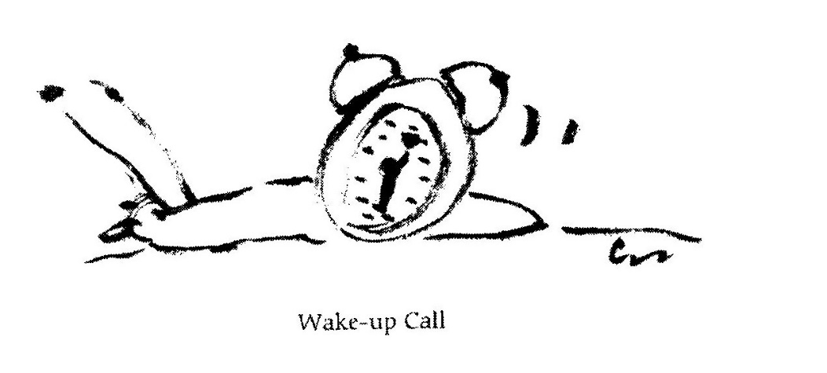

When Philosophy Fails

My cell phone is dying:
You hear me but I can
only, faintly, hear you.

This must, I think, be
a metaphor for a message
vaguely more profound

than my reason for calling
which was to tell you that
my cell phone is dying.

Shrinking

I tried to write a villanelle
but gave it up (what the hell!)

and fell upon my unmade bed
and wrote this clerihew instead

